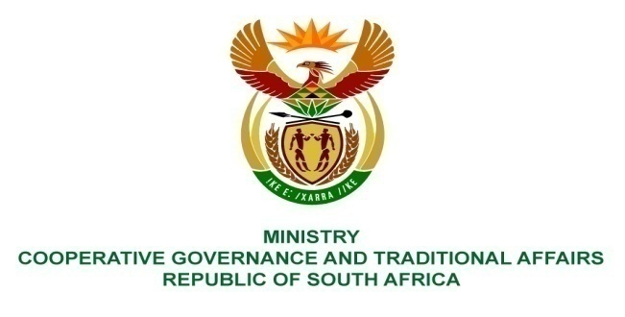
________________________________________________________________________________________

FOR WRITTEN REPLY

NATIONAL ASSEMBLY

PARLIAMENTARY QUESTION NO 4114/2015

PQ 4114. Prof B Bozzoli (DA) to ask the Minister of Cooperative Governance and Traditional Affairs:
(1) What due diligence was conducted by the Municipal Infrastructure Support Agency prior to it entering into a contract with the Siyenza Group to construct toilets in the Northern Cape?
(2) were any checks conducted on Siyenza Group with respect to their (a) tax clearance and (b) Construction Industry Development Board (CIDB) status; if not, why not in each case; if so, (i) what were the outcomes of the specified checks and (ii) why were the (aa) discrepancies and/or (bb) fraudulent nature of the evidence provided not revealed;
(3) whether the way forward to regularising the specified contract will involve an open, competitive bidding process; if not, why not; if so, will the (a) process be open to new contractors and (b) CIDB compliance be verified?
NW4986E
REPLY
- and (2)
A pre-qualification check was done by the MISA Supply Chain Management unit to check compliance with submission of tender compliance documents i.e. tax clearance certificates, BBBEE Certificates, CIDB rating certificates etc. The tax clearance certificate appeared to be legitimate and was taken at face value. Later MISA introduced an additional control measure or due diligence measure of verification of the authenticity of submitted documents (this verification is not a legal requirement in terms of National Treasury supply chain management regulations). It is through this process that MISA was able to detect that the tax clearance certificate that was submitted by Siyenza Group during tendering and the renewed tax clearance certificate were not issued by SARS, which resulted in MISA cancelling the contract.
(3)
MISA’s contract with the Siyenza Group was terminated by mutual agreement on 25 May 2015. Following the termination of the contract, the Department of Water and Sanitation (the project funder) informed MISA that the balance of the remaining projects under the Siyenza Group contract should be handed back to the Department. The Department of Water and Sanitation indicated that it will utilise other contractors already contracted by the Department to complete the project. There was therefore no need for MISA to proceed with any bidding process to finalise the project. .

