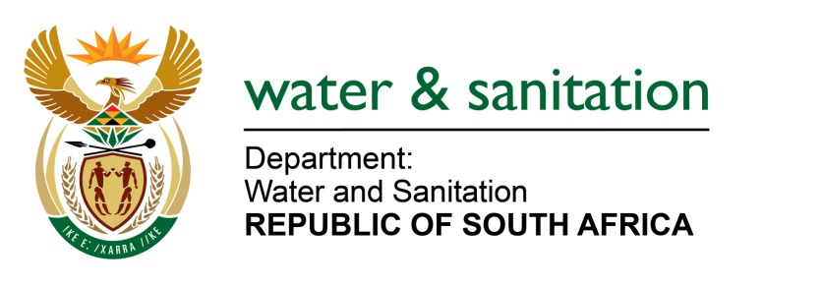

NATIONAL ASSEMBLY

FOR WRITTEN REPLY

QUESTION NO 4107

DATE OF PUBLICATION IN INTERNAL QUESTION PAPER: 4 NOVEMBER 2022
(INTERNAL QUESTION PAPER NO. 44)

4107. Mrs T P Msane (EFF) to ask the Minister of Water and Sanitation:
What steps has his department taken to intervene in the water crisis in the Nkowankowa area of the Greater Tzaneen Local Municipality, where reservoirs have been left unmaintained with the homeless using tanks to relieve themselves?
NW5119E
---00O00---

MINISTER OF WATER AND SANITATION

Water supply challenges in Nkowankowa are a result of tampering with valves on the outlet of the command reservoir and the bypass line to facilitate illegal connections. This caused low pressure on the bulk pipeline resulting in supply interruptions in some areas of Nkowankowa as water could not reach the furthest points of distribution.

The Mopani District Municipality together with the Greater Tzaneen Local Municipality have identified all the valves that needed to be repaired to supply water at Nkowankowa Township and Dan village.

With the assistance of Mokgolobotho Cooperation, which is a community-led structure, all unauthorized connections to the rising main were identified and removed. Water supply to Mokgolobotho settlement has since been restored. Leakages caused by unauthorised connection were identified and repaired.

---00O00---

