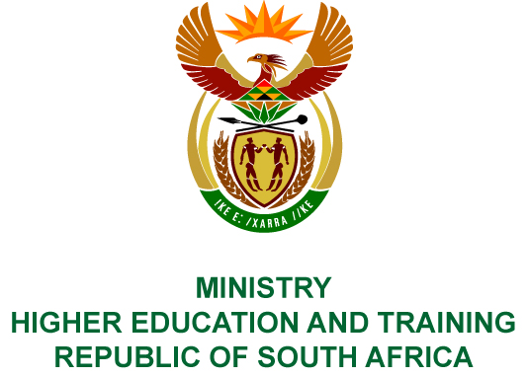
Private Bag X893, Pretoria, 0001, Tel: 012 312 5555, Fax: 012 323 5618
Private Bag X9192, Cape Town, 8000, Tel: 021 469 5150, Fax: 021 465 7956
MEMORANDUM FROM THE PARLIAMENTARY OFFICE
NATIONAL ASSEMBLY
FOR WRITTEN REPLY
QUESTION 410
DATE OF PUBLICATION OF INTERNAL QUESTION PAPER: 01/03/2019
INTERNAL QUESTION PAPER NO 05 OF 2019
Adv A de W Alberts (FF Plus) to ask the Minister of Higher Education and Training:
(1) Whether, with reference to her reply to question 2633 on 17 October 2018, she is now in a position to indicate whether her department's higher education language policy, of which the concept was published in the Government Gazette of 23 February 2018, has already been finalised; if not, what (a) processes are still outstanding and (b) is the timeframe for finalisation; if so, by what date will it be published;
(2) whether her department has received and considered the submissions of (a) the SA Academy for Science and Arts, (b) the Afrikaans Language Board and (c) Afriforum; if not, what is the position in this regard; if so, what are the relevant details in each case;
(3) whether, if the specified policy has not yet been finalised, she will consider holding a symposium to fine-tune it; if not, what is the position in this regard; if so, what are the relevant details;
(4) whether she has found that the policy is in compliance with her obligation under subsection 6(4) of the Constitution of the Republic of South Africa, 1996, to manage and monitor the use of the official languages by means of legislative and other measures, since subsection 27(2) of the Higher Education Act, Act 101 of 1997, has the above as underlying basis;
(5) whether she will make a statement on the matter?
NW473E
REPLY:
- The Department has not yet finalised the Language Policy for Higher Education, which was published in February 2018 for public comment.
- The Department has developed a further draft of the policy taking into consideration all the public comments received. The draft policy will be taken through the Socio-Economic Impact Assessment (SEIAS), which is a necessary process for all government policies, bills and regulations before approval for implementation. Parallel to the SEIAS process, a draft will be submitted to the Council on Higher Education (CHE) for advice, as required by the Higher Education Act (Act 101 of 1997, as amended). These two processes may invariably take about four months to complete (May-August 2019). Feedback from the abovementioned processes may lead to further amendments to the draft policy and will feed into the development of a final draft for publication and implementation.
- The policy will be finalised during 2019 once the above processes have been completed. It is envisaged that the policy will be implemented in 2020 when stakeholders, in particular the universities, have been taken through the revisions.
- The Department received comments from a wide range of stakeholders. Submissions from all stakeholders have been considered taking into account the values of equity and the need to address the historical marginalisation of African languages as provided for in the Constitution of the Republic of South Africa (1996).
        - The Department received a submission from the SA Academy for Arts and Science. The Academy welcomed the revised Language Policy for Higher Education and proposed that specific universities be assigned to develop indigenous South African languages. It called for research to be undertaken to establish guiding principles and procedures for the development of new terminology for African languages. Moreover, the Academy proposed that a core cohort of lecturers proficient in African languages be developed to ensure that there are lecturers who can teach in these languages.
        - No submission was received from the Afrikaans Language Board.
        - Afriforum welcomed the review of the policy and called for a funding allocation to be made in support of multilingualism at universities. It underscored the fundamental right of learners/students to receive education in their mother tongue or the language of their choice. It supported the proposed partnerships with the Department of Basic Education in promoting the development of all indigenous languages in South Africa. It further welcomed the explicit reference to Afrikaans as an indigenous South African language in the policy.
- The Department has already held a number of symposiums and seminars on this matter and is not planning to hold any others before the policy is finalised. However, the Department will continue to engage with universities and other relevant bodies regarding the implementation of the policy once it has been published.
- The revision of the Language Policy for Higher Education is being done in compliance with the Constitution of the Republic of South Africa, 1996, and the Higher Education Act (Act 101 of 1997, as amended).
- The Minister will communicate to all stakeholders once the policy has been published in the government gazette for implementation.

