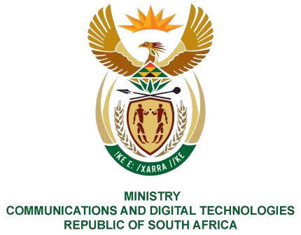
PARLIAMENT OF THE REPUBLIC OF SOUTH AFRICA
NATIONAL ASSEMBLY
WRITTEN REPLY

QUESTION NO: 41
DATE OF PUBLICATION: 10 February 2023
QUESTION PAPER NO: 01

Ms T Bodlani (DA) to ask the Minister of Communications and Digital Technologies: [Interdepartmentally transferred from Police with effect Monday, 13 February 2023]

Whether, with reference to her reply to question 4481 on 21 December 2022, charges were brought against any of the specified individuals implicated in issuing fraudulent vehicle licences?
NW41E REPLY:

I have been advised by SAPO as follows:
Yes, charges have been brought against individuals implicated in issuing fraudulent vehicle licenses:

- 24 criminal cases have been registered with the South African Police Services (SAPS) for fraud and contravention of the section 7 of the Cybercrimes Act No. 19 of 2020 - unlawful acquisition, possession, provision, receipt or use of a password, access code or similar data or device.

- Internal disciplinary proceedings have also been instituted for contravention of the Cybercrimes Act and not protecting usernames and passwords as well as not following policies as required by the Road Traffic Management Corporation (RTMC):

87 employees were identified for contravening the Cybercrimes Act and policy:
  - 3 employees resigned prior to their suspension;
  - 84 employees in total were suspended, of which 15 disciplinary hearings have been concluded and following a guilty conviction, these employees were dismissed. 69 employees are currently on suspension awaiting conclusion of the disciplinary processes.

Thank You.

PQ 41: Hon.T Bodlani (DA) to ask the Minister of Communications and Digital Technologies

PQ 41: Hon. M Bagraim (DA) to ask the Minister of Communications and Digital Technologies

