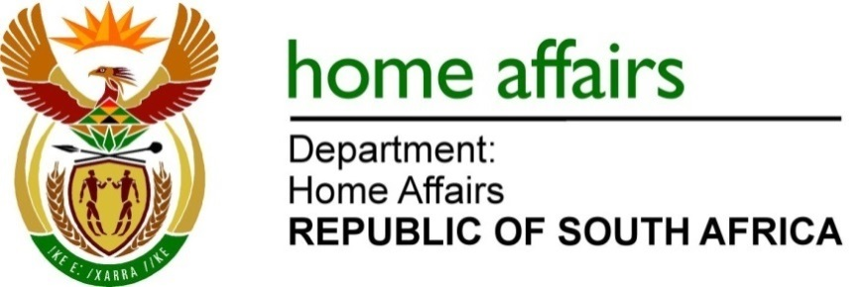

QUESTION FOR WRITTEN REPLY

QUESTION NO. 409

DATE OF PUBLICATION: FRIDAY, 25 FEBRUARY 2022

INTERNAL QUESTION PAPER 4 – 2022

409. Ms L L van der Merwe (IFP) to ask the Minister of Home Affairs: [59] [Question submitted for oral reply now placed for written reply because it is in excess of quota (Rule 137(8))]:
With regard to the address by the President of the Republic, Mr M C Ramaphosa, on 18 September 2019, wherein he alluded to the public’s frustration stemming from the tendency to disregard South Africans for employment in preference of foreign nationals to undercut wages, what steps have been taken by his department since the President’s address to investigate (a) the status of visas awarded to foreign nationals to work in the Republic and (b) those who have obtained documents visas and/or identity documents illegally? NO464E

REPLY:
- There are two processes in the Department that deal with status of visas awarded to foreign nationals to work in the Republic. The first process is ongoing and is handled by Counter-corruption branch of the Department. The branch benefits a lot from tip-offs by members of the public

The second process is that in February last year, after learning how Bushiri obtained his documents to be in the country, I set up a team headed by the former DG in the President’s office, Dr Cassius Lubisi to review all the permits issued by the Department since 2004. These includes work visas.

- Apart from the Counter-Corruption Unit, Home Affairs also has an inspectorate unit that investigates, detect and open cases or withdraw documents that were acquired irregularly or illegally. Transgressors are then deported.
END

