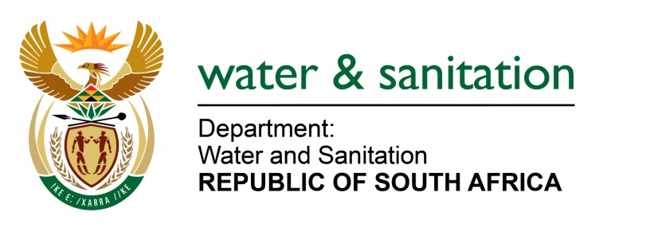

NATIONAL ASSEMBLY

FOR WRITTEN REPLY

QUESTION NO 4086

DATE OF PUBLICATION IN INTERNAL QUESTION PAPER: 4 NOVEMBER 2022
(INTERNAL QUESTION PAPER NO. 44)

4086. Mrs S M Mokgotho (EFF) to ask the Minister of Water and Sanitation:
On what date will adequate water supply be provided for the community of Boitekong in Ward 19 in Rustenburg, North West province, which is currently without water and has been requesting the municipality to make provisions since 2016?
NW5098E
---00O00---

MINISTER OF WATER AND SANITATION

Due to the current high-water demand exacerbated by the ongoing power outages, the Rustenburg Local Municipality (LM) is implementing water demand management in the greater Boitekong areas including the new stands (Extention 13). According to the Rustenburg LM, the water restrictions schedules have been communicated with relevant Ward Councillors and the affected residents.

In the medium to long term, funds have been made available through the Municipal Infrastructure Grant (MIG) administered by Department of Cooperative Government and Traditional Affairs (COGTA) for the upgrade of Bospoort Water Treatment Works from the 12ML/d to 24ML/d. I have been advised that the outstanding mechanical and electrical works are envisaged to be completed by the end of June 2023. This will ensure adequate water provision to the Boitekong area.

---00O00---

