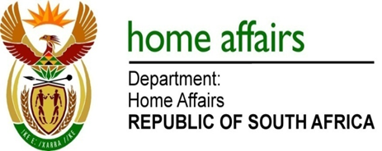

NATIONAL ASSEMBLY

QUESTION FOR WRITTEN REPLY

QUESTION NO. 4083

DATE OF PUBLICATION: Friday, 20 November 2015

INTERNAL QUESTION PAPER 50 OF 2015

4083. Mr M Bagraim (DA) to ask the Minister of Home Affairs:

With reference to his department’s 2014-15 Annual Report, what are the (a) reasons and (b) details of the significant increases in irregular expenditure from previous financial years? NW4954E
REPLY:

- The amount of irregular expenditure incurred by the Department of Home Affairs increased from R730 000 in the 2013/14 financial year to R1 809 000 in the 2014/15 financial year. The reasons for the increase in the amount disclosed as irregular expenditure are:

- Use of single quotation without approval for a deviation;
- Motivation for a deviation was considered not justifiable by the Auditor General;
- Failure to incorporate local content component in the bid for the office furniture; and
- The controls that have been introduced by the department to effectively detect and report all irregular expenditure. In this regard, it should be noted that the department itself identified 50% of the irregular expenditure disclosed in the 2014/15 financial year.

- Details of the irregular expenditure for 2014/2015 financial year are attached as Annexure A.

