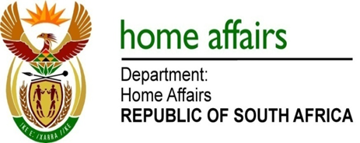

NATIONAL ASSEMBLY

QUESTION FOR WRITTEN REPLY

QUESTION NO. 4082

DATE OF PUBLICATION: Friday, 20 November 2015

INTERNAL QUESTION PAPER 50 OF 2015

4082. Mr M Bagraim (DA) to ask the Minister of Home Affairs:

Whether any reasons have been given by his department as to why ministerial commitments in terms of improving audit findings are still in progress when they were due at the end of March 2015; if not, why not; if so, what are the relevant details? NW4953E
REPLY:

Ministerial commitments are ongoing in nature. The assessment as to whether these commitments were implemented or are still in progress is done by the Auditor-General of South Africa (AGSA). Until such time as the department obtains a clean audit outcome, the AGSA is likely to report that these ongoing Ministerial commitments will remain work in progress. Clearly the onus rests on the department to convince the AGSA that it has improved its asset management, accountability of reporting from the regions, leadership, financial accountability, record keeping and has implemented proper financial management processes and credible action plans before the AGSA will agree that these commitments were fully implemented.

