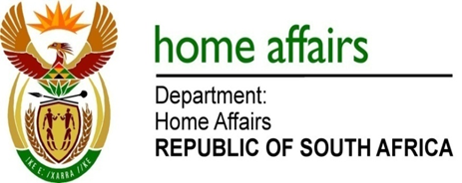

NATIONAL ASSEMBLY

QUESTION FOR WRITTEN REPLY

QUESTION NO. 4080

DATE OF PUBLICATION: Friday, 20 November 2015

INTERNAL QUESTION PAPER 50 OF 2015

4080. Mr E J Marais (DA) to ask the Minister of Home Affairs:

(a) What has been done to address the lengthy payment times of creditors by the Government Printing Works (GPW) and (b) how does this impact on the GPW’s finances?
NW4951E
REPLY:

- During the 2014/15 financial year, the Government Printing Works (GPW) took on average less than 25 calendar days to pay its creditors, including suppliers from abroad. There are no lengthy payment cycles.

- The GPW pays its suppliers during the normal course of business and thus there is no negative effect on its finances.

