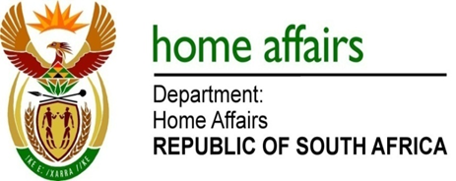

NATIONAL ASSEMBLY

QUESTION FOR WRITTEN REPLY

QUESTION NO. 4079

DATE OF PUBLICATION: Friday, 20 November 2015

INTERNAL QUESTION PAPER 50 OF 2015

4079. Dr G A Grootboom (DA) to ask the Minister of Home Affairs:

Why, with regard to improved operating profit and reserves at the Government Printing Works (GPW), does the GPW not report any major interest earned? NW4950E
REPLY:

The Government Printing Works (GPW), as a government owned business, and a Government Component, must seek permission from National Treasury at the end of each financial year to retain surpluses generated from its operations during that financial year. Once permission is granted the GPW is compelled to bank that surplus in the Paymaster General’s Account, which does not generate interest. It then uses those surpluses in subsequent years to fund the renovation of its facilities, and the purchase of new printing equipment.

