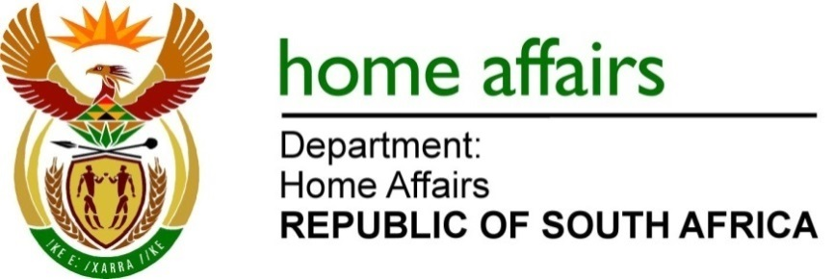
NATIONAL ASSEMBLY

QUESTION FOR WRITTEN REPLY

QUESTION NO. 4061

DATE OF PUBLICATION: FRIDAY 4 November, 2022

INTERNAL QUESTION PAPER 44 – 2022

4061. Ms N K Sharif (DA) to ask the Minister of Home Affairs:

(1) Whether, with regard to the responsibilities of his department in relation to the Alteration of Sex Description and Sex Status Act, Act 49 of 2003, he will furnish Ms N K Sharif with all internal research that his department has conducted in terms of its responsibilities in relation to the specified Act; if not, why not; if so, what are the relevant details;

(2) what total number of appeals has he received, challenging the decision of his department to reject an alteration of sex description application, since the inception of the Act;

(3) whether he will furnish Ms N K Sharif with a statistical breakdown of his ruling on such appeals; if not, why not; if so, what are the relevant details;

(4) whether any members of the Trans Activist Coalition have been included in the drafting processes of the amended Identifications Act, Act 68 of 1997, which will be presented to Cabinet in 2023? NW5069E

REPLY:
- No internal research has been conducted as the department’s responsibility and mandate as guided by Alteration of Sex Description and Sex Status Act, Act 49 of 2003, is to process applications in this respect.

- None received.

- Not applicable as no appeals have been received.

- No member of the group, identified, has formed part of the drafting team. The Bill will be gazetted for public consultation wherein comments and inputs are expected, inter alia, from the community identified.

END

