Annexure “A”

MPOFANA LOCAL MUNICIPALITY

WATER CHALLENGES

Joint Program between UMgungundlovu DM, Mpofana LM and Umgeni Water to overcome Water Challenges at Mpofana whilst waiting for new Bulk Water Supply Project

MARCH 2019

Purpose
The purpose of this report is to present joint strategy to overcome water challenges for Mpofana Local Municipality. The strategy has been developed jointly by Mpofana LM, UMgungundlovu DM and Umgeni Water to minimise the risks of water supply interruptions to Mpofana Local Municipality.

Background
The design capacity of Mpofana waterworks is 6 Ml/d comprising of a raw pump station - housing four pump sets (2x39 kW motors on duty and 2x137 kW motors - one duty and one standby), clarifiers, filters, disinfection system, chlorine chamber and reservoirs. Due to the growing water demand in the area the plant was augmented with a 2Ml/d package plant.
The raw water pump station has been tested and can only deliver 7 Ml/d. The demand for Mpofana and surrounding areas is estimated to currently be around 8.5 Ml/d. The increase in demand has resulted in some of the UMgungundlovu DM (uMDM) reservoirs being closed off at night to ensure sufficient storage for the following day. One such example is the Bruntville Reservoir.

Plant issues
- The raw water pump station can only deliver a maximum of 7 Ml/d.
- Currently there is no duty /standby for the 39 kW pumps, both are operated simultaneously to give the 2.5 Ml/d combined output.
- The 137 kW pump can deliver a maximum of 4.5 Ml/d each and both pumps cannot be operated simultaneously.
- The raw water pump station is failing to deliver 7 Ml/d presently.
- In addition, the system is highly constrained due to high water wastage from the community with number of illegal connections especially car washes in the area

Power Issues
- The plant is affected regularly by power issues from cable theft and unreliable supply. These factors cause an already strained network to drain fast. It takes an extended period of time to build up supply after power outages at Mpofana.

- Recent power outages
  - 17/02/2019 – 02h00 to 14h30 (12 ½ hours)
  - 20/02/2019 – 04h15 to 20h00 on 21/02/2019 (approx. 40 hours)
  - 26/02/2019-18h45 to 21h35 (approx. 3 hours)
These outages were not from Eskom but from Mpofana Local Municipality. The Electrical Department of the Local Municipality also take a long time to restore power, at times.

Heavy Rains
- Heavy rains affect raw water quality, thus making it difficult to treat water with high turbidity.
- The plant is not designed for treating unusually high turbid water efficiently. The high turbidity causes filter clogging.
- Mud and debris getting into the system (pipes and suction chambers) during the rainy season reduces flow to the plant and creates blockages in the system.

LONG TERM PLANS

Greater Mpofana
Project: Bulk Water Supply Scheme
The Regional Bulk Water Supply Scheme augmentation has been dived into three distinct phases, the implementation of these phases will to overlap in order to complete the scheme in as short a period as possible. Implementation of Phases 2 and 3 is however dependant on the availability of RBIG funding.

Phase 1 of the project is being managed by Umgeni Water’s in-house design and Project Management Office, and involves the following infrastructure:-
- 13.5km of 660mm diameter steel pipeline from Rosetta WTW to Bruntville reservoir and 8km x 660mm diameter steel pipe to Nottingham road reservoir.
- 20Ml/l Rosetta WTW complete with pump station, interconnecting pipework and other ancillary works.
- Construction of Reservoirs (12Ml, 5Ml and 1Ml)
- Construction of an 8km 650mm steel pipeline to Nottingham Road
Later phases of this project will extend further to Lidgetton, Curry’s Post and uMsinga Local Municipality.

Phase 1 layout is shown in the figure below

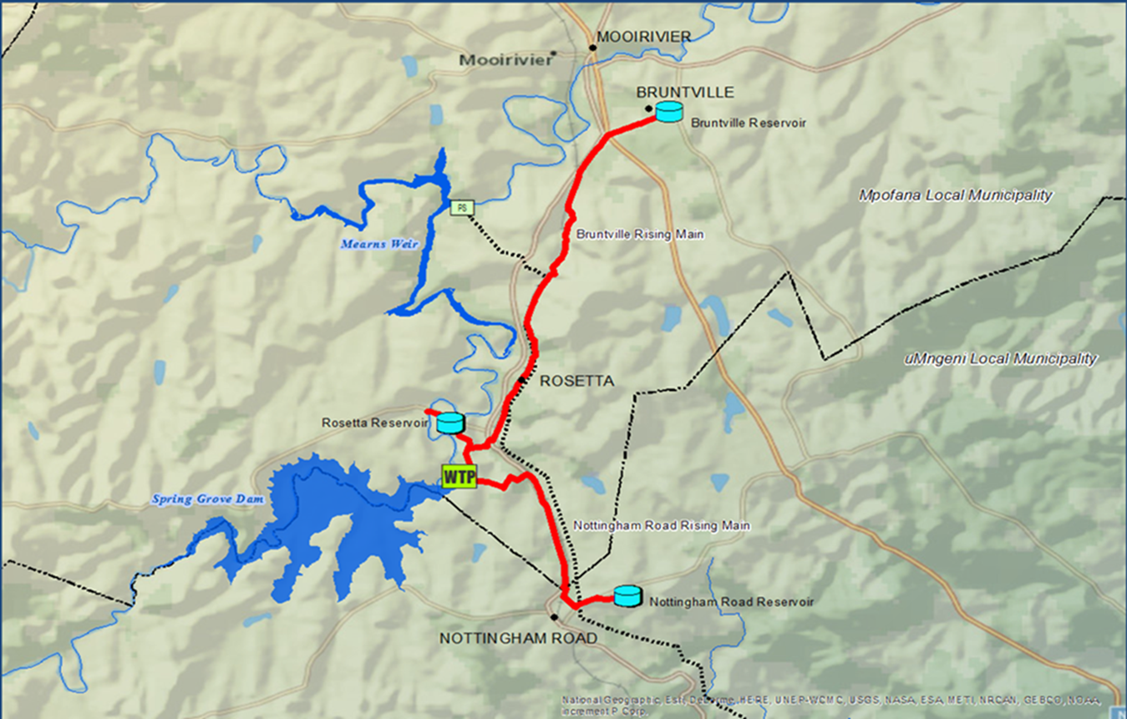

Progress Summary

Budget: Total Approved Budget is R757.343m
PHASE | DESCRIPTION | RESPONSIBLE ENTITY | STATUS
Phase 1 | Construction of 20Ml/d Water Treatment Works | Umgeni Water / Basil Real | 72% Complete
Phase 1 | Construction of Bruntville Pipeline | Umgeni Water / WKCSA | 83% Complete-  Contract is terminated
Phase 1 | The construction of 12ML, 5ML and 1ML Reservoirs | Umgeni Water/Afrostructures | 100% Complete
Phase 1 | Manufacture, Supply and Delivery of 13.2 km of DN 650 pipes | Umgeni Water / Hall Longmore | 100% complete (PO for additional pipes issued.)
Phase 1 | Construction of Nottingham Road Pipeline | Umgeni Water/ TCTA | 100% Complete (Preparation of O&M and AS Built drawings)

Details of other contracts:
  - Contract No. 2015/013: Construction of a 20ML Rosetta Water Treatment Works.

The Contract was awarded to Basil Read (Pty) Ltd.

The following contractual dates and information apply to the contract:
- Contractor Award Value R 304 765 117.00
- Commencement Date 01 August 2016
- Contract Duration 78 weeks
- Planned Completion Date 30 August 2019
- Percentage Works Completed 72% Complete
- Contract status Current

  - Contract No. 2015/220: Construction of 13 km, DN 650 steel pipeline to Bruntville
The Contract was awarded to WK Construction SA (Pty) Ltd.

The following contractual dates and information apply to the contract:

- Contractor Award Value R 95 854 429.46 (excl. VAT)
- Commencement Date 13 January 2017
- Contract Duration 100 weeks
(Incl. approved Extension of Time)
- Planned Completion Date Contract Terminated
- Percentage Works Completed 82% Complete
- Contract status Current

  - Contract No. 4600000055: Construction of 8 km, DN 650 steel pipeline to Nottingham Road
TCTA is an Implementing Agent: (Constructed by WBHO)
The following contractual dates and information apply to the contract:
- Contractor Award Value R 85 506 488.15
- Commencement Date 23 July 2014
- Contract Duration 104 weeks
- Planned Completion Date 31 July 2016
- Percentage Works Completed 100 % Complete
- Contract status Complete, hand-over in progress

  - Contract No. 2014/124: Construction of Reinforced Concrete Reservoirs (12 Ml, 5 Ml & 1 Ml)
The contract was awarded to Afrostructures (Pty) Ltd.

The following contractual dates and information apply to the Contract:
- Contractor Award Value R 58 658 625.90
- Commencement Date 01 July 2015
- Contract Duration 54 weeks
- Planned Completion Date 01 September 2016
- Percentage Works Completed 100 % Complete
- Contract status Complete and handed over

Temporary Jobs Created
A total 120 decent jobs have been reported so far each being equivalent to 100 person days of work.

MEDIUM TERM PLAN OF ACTION
- Umgeni Water (UW) to clean of the clarifier of the package plant
- UW to replenish the filter media on all three pressure sand filters of the package plant
- Empty and clean Reservoirs 4 and 5

SHORT TERM PLAN OF ACTION

Raw Water Pumps and Suction Chambers
- UW to increase the frequency of cleaning the suction chambers if the delivery pressure starts to drop on the pumps or after heavy rains
- Cleaning of the suction chambers to be properly planned between UW and UMDM not to affect the water supply
- PRS to be sent out for the scouring of rising main and this must be planned by UW and UMDM
- UW artisan to increase the frequency of inspecting the raw water pumps
- UW water to check if the non- return valve is still working correct on the pumps

Water Rationing
- Water rationing will need to take place due to number on internal leaks within properties. In case the water is not switched off at night the reservoir levels continue to drop.
- Water Rationing times: 20h15- 06h30 Areas main affected Bruntville and Townview

Main Plant
- UW increased the filter backwash frequency to improve the output
- UW ordered two back wash pumps that will be delivered in 6 weeks’ time, to improve filter backwash system
- UW to look at the system that can be used for reservoir level measurement
- UMDM to carry on with the meter strainers cleaning programme
- UMDM to close their system to prevent the reservoir from running dry as and when necessary.

Mpofana power issues and water wastage
- Mpofana issues commitment to ensure non-interruption of electricity supply 24/7.
- Mpofana Municipality to ensure fixing of water leaks in municipal buildings.

CONCLUSION
- Councillors and officials for both Mpofana Municipality and UMgungundlovu DM to embark on major water wastage campaign
- UMgungundlovu to attempt to fix leaks on standpipes on the yard it being noted that this point is beyond water meter.
- Consumer education campaign to be undertaken throughout the whole Mpofana Municipality to minimise wastage
- Communication strategy to be implemented to communicate times at night when water is shut.

