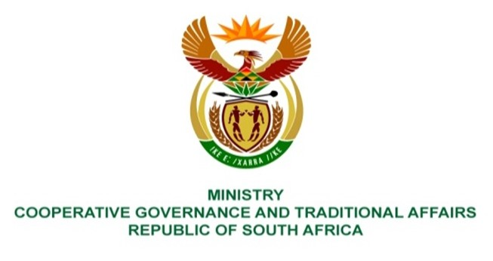
NATIONAL ASSEMBLY
QUESTION FOR WRITTEN REPLY
QUESTION NUMBER 4035
DATE OF PUBLICATION: 04 NOVEMBER 2022

4035. Ms E R J Spies (DA) to ask the Minister of Cooperative Governance and Traditional Affairs:

Whether her department and/or any entity reporting to her have budgeted for (a) financial donations and/or (b) sponsorships in the (i) 2018-19, (ii) 2019-20, (iii) 2020-21 and (iv) 2021-22 financial years; if not, why not, in each case; if so, what total amount was (aa) budgeted and (bb) spent in each specified financial year? NW5043E

REPLY:

The Departments of Cooperative Governance (DCoG) and Traditional Affairs (DTA) alongside the Municipal Infrastructure Support Agent (MISA) have not budgeted for financial donations and/or sponsorships in the (i) 2018-19, (ii) 2019-20, (iii) 2020-21 and (iv) 2021-22 financial years.

