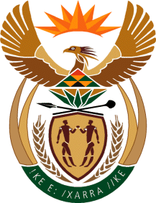

MINISTRY: COMMUNICATIONS
REPUBLIC OF SOUTH AFRICA
Private Bag X 745, Pretoria, 0001, Tel: +27 12 473 0164 Fax: +27 12 473 0585
Tshedimosetso House,1035 Francis Baard Street, Tshedimosetso House, Pretoria, 1000

NATIONAL ASSEMBLY
QUESTION FOR WRITTEN REPLY
QUESTION NUMBER: 4031 OF 2015
DATE OF PUBLICATION: 30 OCTOBER 2015
Ms V van Dyk (DA) to ask the Minister of Communications:
(1) Whether, the SA Broadcasting Corporation did indeed stop to broadcast news bulletins in any other language than English on its news channel aired on DSTV channel 404 with effect from 1 April 2015 (details furnished); if not, what is the position in this regard; if so: (a) what was the rationale behind this decision and (b) who took this decision; (2) whether any form of a public consultation process took place before this decision was implemented; if not, why not; if so, what are the further relevant details of the (a) persons consulted and (b) outcomes in each case? NW4899E
_____________________________________________________________

REPLY: MINISTER OF COMMUNICATIONS

(1) Yes, the SABC has discontinued the broadcast of news bulletins in other languages on its DSTV channel 404.
(1)(a) The decision was premised on the fact that the channel now broadcast in all the Sub-Saharan countries and is not limited to South African audiences.

(2) There were no public consultations undertaken because the channel is not a free to air platform.

MR NN MUNZHELELE
DIRECTOR GENERAL [ACTING]
DEPARTMENT OF COMMUNICATIONS
DATE:

MS AF MUTHAMBI (MP)
MINISTER OF COMMUNICATIONS
DATE:

