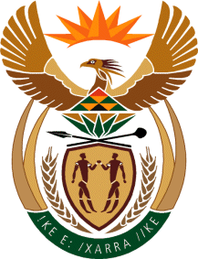

MINISTRY: COMMUNICATIONS
REPUBLIC OF SOUTH AFRICA
Private Bag X 745, Pretoria, 0001, Tel: +27 12 473 0164 Fax: +27 12 473 0585
Tshedimosetso House,1035 Francis Baard Street, Tshedimosetso House, Pretoria, 1000

NATIONAL ASSEMBLY
QUESTION FOR WRITTEN REPLY
QUESTION NUMBER: 4023 of 2015

Mrs M R Shinn (DA) to ask the Minister of Communications:
Whether, with reference to her reply to question 3656 on 3 November 2015, she will provide a comprehensive answer to all questions posed; if not, why not; if so, by when can the comprehensive reply be expected? NW4891E
___________________________________________________________________REPLY: MINISTER OF COMMUNICATIONS

The Department of Communications is of the view that the reply provided to Parliamentary Question 3656 is comprehensive enough, unless if the Honourable member can be more specific.

MR NN MUNZHELELE
DIRECTOR GENERAL [ACTING]
DEPARTMENT OF COMMUNICATIONS
DATE:

MS AF MUTHAMBI (MP)
MINISTER OF COMMUNICATIONS
DATE

