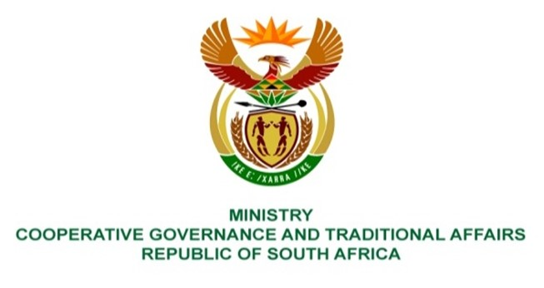
NATIONAL ASSEMBLY
QUESTIONS FOR WRITTEN REPLY
QUESTION NUMBER 4008

4008. Mr K Ceza (EFF) to ask the Minister of Cooperative Governance and Traditional Affairs:
With reference to the Makana Local Municipality which is amongst the 64 municipalities that have been identified as dysfunctional in her department’s report to Cabinet and is said to have been deteriorating since the visit of the Portfolio Committee on Cooperative Governance and Traditional Affairs, with communities sighting the same issues of the lack of water and poor roads, what conclusive evidence and outcomes were drawn from the invocation of section 106 of the Local Government: Municipal Systems Act, Act 32 of 2000, in the specified municipalities? NO4993E

Reply:
It is the responsibility of the MEC for Local Government to invoke section 106 of the Local Government: Municipal Systems Act, Act 32 of 2000. The Department has been informed by the province that there has not been any invocation of section 106 of the Local Government: Municipal Systems Act at Makana Local Municipality.

