NATIONAL ASSEMBLY
WRITTEN REPLY
QUESTION 4001

DATE OF PUBLICATION OF INTERNAL QUESTION PAPER: 16/11/2015
INTERNAL QUESTION PAPER: 49/2015

4001. Mr T R Majola (DA) to ask the Minister of Basic Education:
Whether her department implemented the recommendation of the 2012 National Education Evaluation and Development Unit’s report dated 2 May 2013, which stated that principals must be held accountable for time use in the school; if not, why not; if so, what are the relevant details? NW4869E
RESPONSE:
Yes, the Department is implementing the recommendation progressively. The recommendation as contained in the 2012 National Education Evaluation and Development Unit (NEEDU) report focuses mainly on the role of the Circuit Manager (CM) and principal in time management practices; and Human Resource (HR) policies and procedures including leave management.
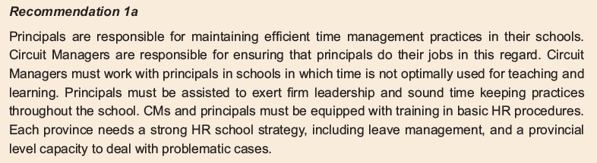
In line with the recommendation, the Department has strengthened the National Strategy for Learner Attainment (NSLA) to monitor and support teaching and learning in schools. One of the key pillars of the NSLA is strong leadership and management. The National Development Plan (NDP) outlines the importance of having sound management in the school to build a strong and coherent set of institutions for delivering quality education, namely “Skilled and dedicated principals to foster a vibrant but disciplined environment that is conducive to learning”. The objectives of the NSLA framework include:

- Enhanced accountability at all levels of the system;
- Greater focus on basic functionality of schools;
- Protecting time for teaching and learning;
- Improved support for teaching and learning; and
- Increased efforts on time on task.

- Training has also been offered in provinces for school principals and circuit managers on curriculum management. A total of 1 224 Circuit Managers and 8 020 principals respectively, were trained from March to September 2015. Among others, the training sought to optimise and strengthen the implementation of the time on task in the delivery of curriculum through teaching and learning in schools.
- f
- The policy on the South African Standard for Principalship has been approved and should be published in a gazette beginning of 2016. The policy foregrounds some key areas for leadership and management in response to the recommendation in the report pertaining to principals, for example:

- Leading teaching and learning in the school – five main kinds of leadership;
- Managing quality of teaching and learning and securing accountability;
- Managing the school as an organisation; and
- Managing human resources (staff) in the school.

- With regard to time management, Provincial Education Departments (PEDs) have their own uniquely tailored programmes to monitor schools according to their contexts. As part of monitoring, the Department of Basic Education (DBE) has developed an instrument to verify management documents such as school time tables, class timetables, personal teacher time tables, leave registers, time book/registers, et cetera. District officials (including Circuit Managers) regularly visit schools for monitoring and support purposes in this regard. At both the provincial and district levels the officials analyse the monitoring reports and develop action plans to support schools.

- The accountability of school principals will be strengthened through the implementation of the Quality Management System (QMS) for school based educators. The QMS makes provision for principals to agree on and sign work plans with their immediate supervisor (i.e. Circuit Manager). The work plan will have clear deliverables that are time bound. Circuit Managers must work with principals in schools to ensure that time is optimally used for teaching and learning.

Although the QMS was agreed to by all parties to the Education Labour Relations Council (ELRC) in November 2014, the QMS will be implemented once all parties signs.

