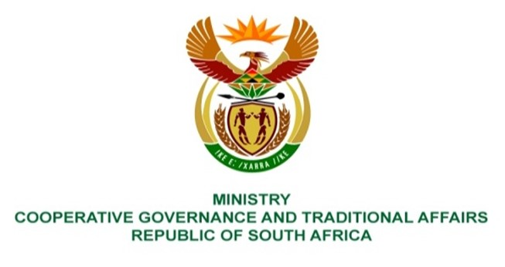

NATIONAL ASSEMBLY
QUESTION FOR WRITTEN REPLY

QUESTION NUMBER 4
DATE OF PUBLICATION: 10 FEBRUARY 2022

QUESTION:

4. Mr I M Groenewald (FF Plus) to ask the Minister of Cooperative Governance and Traditional Affairs:
- Whether all municipalities developed community participation and ward committee funding models as envisaged by the National Framework on the Funding Models for Ward Committees as approved by Cabinet, in terms of which ward committee members may be reimbursed for out-of-pocket expenses; if not, why not; if so, what are the relevant details;
- what was the total average expense in each (a) month and (b) province of ward committee members in the Republic for the past three financial years? NW5E

REPLY:
The information requested varies from one municipality to the other and is not readily available in the Department. The department is in the process of sourcing and verifying information from Provinces and Municipalities to ensure accurate reporting.

