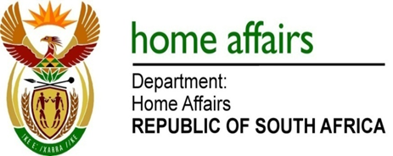

NATIONAL ASSEMBLY

QUESTION FOR WRITTEN REPLY

QUESTION NO. 3976

DATE OF PUBLICATION: FRIDAY, 1 December 2017

INTERNAL QUESTION PAPER 47 OF 2017

3976. Mr M H Hoosen (DA) to ask the Minister of Home Affairs:

Whether, with regard to the report by the Public Protector entitled Inappropriate Moves, the Independent Electoral Commission has acted on all of the recommendations; if not, (a) which recommendations have not been acted upon and (b) what are the reasons in each case; if so, what action was taken with regard to each recommendation? NW4522E
REPLY:

Yes.
- Not applicable
- Not applicable

