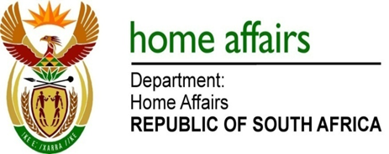

NATIONAL ASSEMBLY

QUESTION FOR WRITTEN REPLY

QUESTION NO. 3974

DATE OF PUBLICATION: FRIDAY, 1 December 2017

INTERNAL QUESTION PAPER 47 OF 2017

3974. Mr M Waters (DA) to ask the Minister of Home Affairs:

Whether any software and/or hardware for the Independent Electoral Commission has been bought from any company registered in the Russian Federation; if so, what (a) is the purpose of the software and/or hardware and (b) is the cost in each case? NW4520E
REPLY:

The Electoral Commission responded as follows:

No.
- Not applicable
- Not applicable

