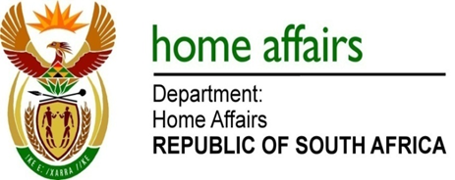

NATIONAL ASSEMBLY

QUESTION FOR WRITTEN REPLY

QUESTION NO. 3973

DATE OF PUBLICATION: FRIDAY, 1 December 2017

INTERNAL QUESTION PAPER 47 OF 2017

3973. Mr M Waters (DA) to ask the Minister of Home Affairs:

Whether any (a) staff member and/or (b) commissioner of the Independent Electoral Commission has ever been to the Russian Federation for any (i) observer mission and/or (ii) any other official visit; if so what (aa) are the names of the individuals that went to Russia, (bb) was the purpose of the visit in each case, (cc) were the dates of each trip and (dd) were the total costs of each trip? NW4519E
REPLY:
The Electoral Commission responds as follows:

- Yes
- Yes
- Not applicable

(aa) The delegation consisted of Commissioner Terry Tselane; Ms Nkaro Mateta; Mr Thabo Masemula and Ms Belinda Mbeleni.

(bb) Election Observation

(cc) 9 – 16 September 2014 for Ms Mateta, Mr Masemula and Ms Mbeleni, and 7-9 September 2014 for Commissioner Tselane.

(dd) The total cost of the trip was R136 558

