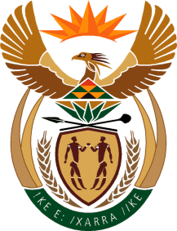

MINISTRY OF TOURISM
REPUBLIC OF SOUTH AFRICA

Private Bag X424, Pretoria, 0001, South Africa. Tel. (+27 12) 444 6780, Fax (+27 12) 444 7027
Private Bag X9154, Cape Town, 8000, South Africa. Tel. (+27 21) 469 5800, Fax: (+27 21) 465 3216

QUESTION FOR WRITTEN REPLY:
Question Number: 3970
Date of Publication: 01 December 2017
NA IQP Number: 47
Date of reply: 14 December 2017

Mr J Vos (DA) to ask the Minister of Tourism

Whether there is a reliable water supply to the Royal Khalanga Accommodation Lodge in Limpopo; if not, by what date will a reliable water source be put in place; if so, what are the relevant details? NW4516E
Reply:
In 2014, three (3) boreholes were drilled within the lodge site and none of these yielded positive results. Subsequent to this attempt, a borehole was drilled some 3km away from the site, and that borehole which yielded water. The water from this borehole was tested and declared fit for human consumption. The borehole was equipped and a pipeline connected to supply water to the lodge. The same borehole also supplied water to the local Cultural Village. The supply of water from the borehole was sufficient to complete the work required for the project and for operations once the project was handed over by the Department to the Owning Entity, the Valoyi Traditional Authority Trust, in May 2016.

