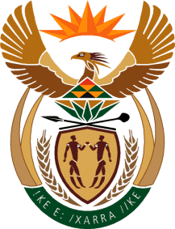

MINISTRY OF TOURISM
REPUBLIC OF SOUTH AFRICA

Private Bag X424, Pretoria, 0001, South Africa. Tel. (+27 12) 444 6780, Fax (+27 12) 444 7027
Private Bag X9154, Cape Town, 8000, South Africa. Tel. (+27 21) 469 5800, Fax: (+27 21) 465 3216

Ref: TM 2/1/1/10

NATIONAL ASSEMBLY:

QUESTION FOR WRITTEN REPLY:
Question Number: 3968
Date of Publication: 01 December 2017
NA IQP Number: 47
Date of reply: 15 December 2017

Mr J Vos (DA) to ask the Minister of Tourism

What (a) are the details of the marketing initiatives undertaken in 2017 to promote the Royal Khalanga Accommodation Lodge in Limpopo, (b) is the total cost of the specified marketing initiatives and (c) amounts have been budgeted to promote the lodge in (i) 2018 and (ii) 2019? NW4514E
Reply:

The Department is not responsible for the operation of a project post-handover and therefore is not involved in the marketing initiatives post-handover. This question will need to be referred to the Project Owning Entity who is the Valoyi Traditional Authority Trust.

