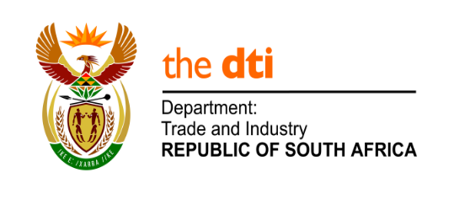

NATIONAL ASSEMBLY

WRITTEN REPLY

PARLIAMENTARY QUESTION 396

DATE OF PUBLICATION: 26 JULY 2019

Mr D W Macpherson (DA) to ask the Minister of the Trade and Industry:
What was the total cost for the investigations, including legal fees and travel with respect to case (a) 2/3/2018, (b) 3/3/2018, (c) 4/3/2018, (d) 5/3/2018 and (e) 6/3/2018 investigated by the Broad-Based Black Economic Empowerment (BBBEE) commission into fraudulent BEE certificates by certain companies (names furnished)? NW1368E

Reply:

I am advised by the B-BBEE Commission and the Director-General for Trade and Industry that no costs that are separately-accounted for were incurred for the investigations on the above mentioned cases.
They advised further that the cases were investigated internally by the investigator who was already on the payroll, no legal fees were incurred as no external advisors were used and no separately accounted-for travel costs were incurred as the pool car of the dti was used to conduct site visits and to serve documents.

-END-

