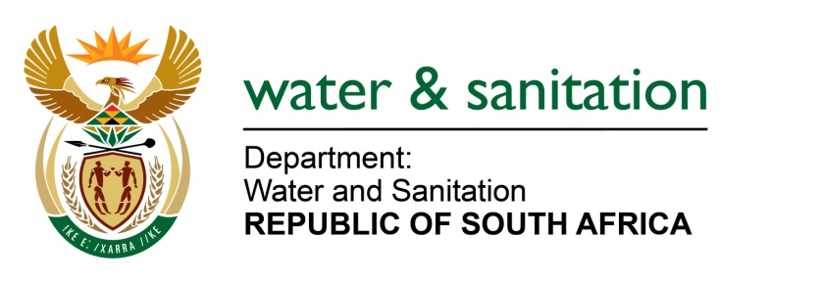

NATIONAL ASSEMBLY

FOR WRITTEN REPLY

QUESTION NO 3959

DATE OF PUBLICATION IN INTERNAL QUESTION PAPER: 6 NOVEMBER 2015
(INTERNAL QUESTION PAPER NO. 48)

3959. Mr L J Basson (DA) to ask the Minister of Water and Sanitation:
With reference to the R918 million under spending of her department’s Programme 4: Regional Implementation and Support, as indicated in its 2014-15 Annual Report, (a) which (i) regions and (ii) municipalities are affected and (b) what are the full relevant details of each project that is affected in each of the specified (i) regions and (ii) municipalities? NW4826E
---00O00---
REPLY:

(a) A number of projects in various regional offices and municipalities will be affected by the disapproval of rollover in that their completion date will be delayed due to budgetary shortfall.

(b)(i) The risk will however be mitigated by the reallocation and prioritisation of the 2015/16 allocation towards some of the affected projects on rollover disapproval.

(b)(ii) This will delay the implementation of new projects which were to start in 2015/16 as their allocation would be reprioritised towards rollover.

--00O00---

