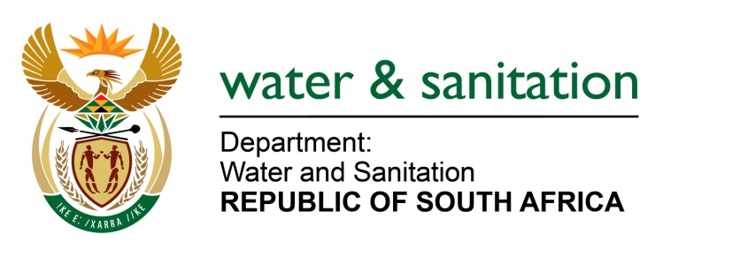

NATIONAL ASSEMBLY

FOR WRITTEN REPLY

QUESTION NO 3958

DATE OF PUBLICATION IN INTERNAL QUESTION PAPER: 6 NOVEMBER 2015
(INTERNAL QUESTION PAPER NO. 48)

3958. Ms T E Baker (DA) to ask the Minister of Water and Sanitation:
(1) With regard to the upgrading of the Mkhondo Local Municipality’s waste water treatment plant in Mpumalanga, (a)(i) when did the upgrading of the specified plant commence and (ii) when is it expected to be completed, (b) what is the total cost of the upgrade to date in terms of the (i) total expected cost and (ii) actual expenditure and (c) in what category will the upgraded plant be placed;
(2) whether the current staffing complement is (a) sufficient and (b) suitably qualified to operate the specified plant; if not, what steps has she taken to address this problem; if so, what are the further relevant details in this regard? NW4825E
---00O00---
REPLY:

(1)(a)(i) The upgrading of the Mkhondo Local Municipality’s waste water treatment plant (WWTP) in Mpumalanga commenced on 29 June 2012.

(1)(a)(ii) The plant was completed on 30 October 2015.

(1)(b) (i) The total cost of the upgrade to date is R 65 980 058.23.

(1)(b)(ii) The total expected cost for the upgrading of the plant is R 59 159 095.50.

(1)(c) The upgraded category of the plant Inlet works and screw pump station includes the following:
- Transfer pipeline and distribution chamber
- Biological Reactor
- Secondary sedimentation tanks
- Return activated sludge (RAS) and scum pump station
- Chlorine contract channels and dosing facility
- Sludge handling and treatment
- Anaerobic digesters

(2) No. The municipality is in the process of appointing a consultant for operation and maintenance for the period of two years which shall ensure sustainability and skill transfer to eight (8) process controllers for Mkhondo Waste Water Treatment Works.

---00O00---

