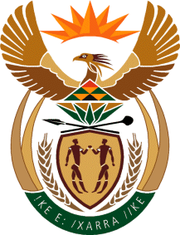

MINISTRY:COMMUNICATIONS
REPUBLIC OF SOUTH AFRICA
Private Bag X 745, Pretoria, 0001, Tel: +27 12 473 0164 Fax: +27 12 473 0585
URL: http://www.gov.za
NATIONAL ASSEMBLY
QUESTION FOR WRITTEN REPLY
QUESTION NUMBER: 3955 of 2015
DATE OF PUBLICATION:

3955. Ms P T van Damme (DA) to ask the Minister of Communications:

With reference to R93 million that was written off by her department as reflected in its 2014-15 Annual Report, (a) what are the names of the (i) companies and/or (ii) persons whose debt was written off and (b) what are the reasons in each case? NW4821E

Reply:
Minister of Communications:

No debts were written off in the 2014/15 financial year.

MR DONALD LIPHOKO
ACTING DIRECTOR-GENERAL
GOVERNMENT COMMUNICATION AND INFORMATION SYSTEM
DATE:

MS AF MUTHAMBI, MP
MINISTER OF COMMUNICATIONS
DATE:

