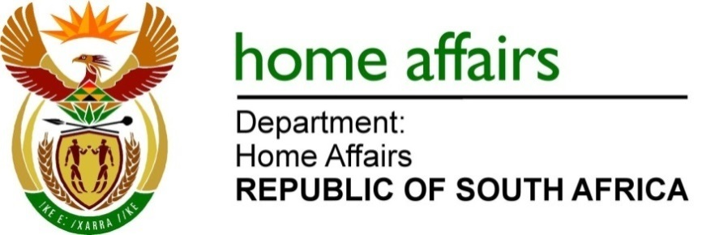
QUESTION FOR WRITTEN REPLY

QUESTION NO. 3954

DATE OF PUBLICATION: FRIDAY 28 OCTOBER 2022

INTERNAL QUESTION PAPER 42 – 2022

3954. Ms A M van Zyl (DA) to ask the Minister of Home Affairs:

(1) What (a) amount does his department owe to the (i) Walter Sisulu Local Municipality and (ii) Senqu Local Municipality, (b) is the age analysis in each case on monies owed and (c) are the details of the (i) building and (ii) use thereof;

(2) whether his department has any plans in place to address the debts; if not, why not; if so, what (a) plan and (b) are the time frames in which the debt will be settled? NW4922E

Draft reply:
(1)&(2)
The Department of Home Affairs (DHA) does not owe Walter Sisulu Local Municipality and Senqu Local Municipality any money for rates and services. In this regard, please note that the municipal accounts for rates and services in respect of buildings occupied by the DHA are managed and paid for by the Department of Public Works and Infrastructure (DPWI). The DHA reimburses the DPWI on a monthly basis for such expenditure.

END

