FOR WRITTEN REPLY

NATIONAL ASSEMBLY
36/1/4/1(201900051)

QUESTION 395

DATE OF PUBLICATION IN INTERNAL QUESTION PAPER: 22 FEBRUARY 2019
(INTERNAL QUESTION PAPER NO 3-2019)

395. Mr M Johnson (ANC) to ask the Minister of Police:

- On which legal provisions does the SA Police Service rely to arrest persons for consuming alcohol in public;

- (a) why do police officers avoid arresting persons who drink in public and (b) what measures does he intend taking to stop such a bad practice that is killing our society, especially the youth?
NW421E
REPLY:

- Schedule 5 of the Constitution of the Republic of South Africa, 1996, (Act No.
108 of 1996) addresses the functional areas of the exclusive provincial legislative competence.

Part 'A' of Schedule 5, clearly states that the issuing of liquor licences falls within the ambit of provincial legislative competence, to rpgulatp the micro- manufacturing and retail sale of liquor through provincial liquor legislation.

The legal implications of Schedule 5 is that, where in the past the liquor industry was governed by only the Liquor Act, 1989 (Act No. 27 of 1989), the liquor industry is now governed by the nine provincial liquor acts and one National Liquor Act, 2003 (Act No. 59 of 2003).

Provincial legislative framework
The provincial liquor legislations are administered by the respective Provincial Liquor Boards/Authorities/Regulators, in the nine provinces. The provincial liquor legislation is only applicable in the respective provinces. The following legislations listed below, include offences for drinking in public and being under the influence in public and are utilised by the South African Police Service (SAPS) to charge offenders:

Eastern Cape Liquor Act, 2003 (Act No 10 of 2003);
  - Section 59(d)(i), being drunk or disorderly in or on any road, street, lane, thoroughfare, square, park or market.
  - Section 59(e), consuming liquor in any road, street, lane or thoroughfare, or on vacant land adjacent thereto, in an urban area or other area subdivided into erven or plots.

Free State Gambling and Liquor Act, 2010 (Act No 6 of 2010):
  - Section 128(3)(a)(ii), a person who is drunk in or on a place to which the public has access.
  - Section 128(3)(d), a person who consumes liquor in any street, lane, thoroughfare or vacant land adjacent thereto in urban/rural area subdivided into erven or plots, read with Section 128(5).

Gauteng Liquor Act, 2003 (Act No 2 of 2003);
  - Section 127(c), being intoxicated in, on or near any public place.
  - Section 127(d), drink liquor in, on or near any public place.

Limpopo Province, Liquor Act, 1989 (Act No 27 of 1989);
  - Section 154(1)(c)(i), any person who is drunk in, on or near any road, street, lane, thoroughfare, square, park, or market.
  - Section 154(1)(d), subject to Subsection 2, consumes any liquor in any road, street, lane or thoroughfare, or on vacant land adjacent thereto, in an urban area or other area subdivided into erven or plots, with streets bound by such erven or plots.

Mpumalanga Liquor Licensing Act, 2006 (Act No 5 of 2006);
  - Section 59(1)(c), being drunk in, on, near a road, lane, thoroughfare, square, park, shop, warehouse, public garage, entertainment place, eating-house, racecourse or place where the public has access.
  - Section 59(1)(d), consuming liquor in a road, lane thoroughfare, vacant land adjacent thereto, urban area, erven or plots, with streets bounded by such erven or plots.

Northern Cape Liquor Act, 2008 (Act No 2 of 2008);
  - Section 46(1)(h), consuming liquor or being drunk in, on or at a public place, including any road, street, lane, park, market, shop or warehouse, to which the public has access to.

North West Province, Liquor Act, 1989 (Act No 27 of 1989);
  - Section 154(1)(c)(i), any person who is drunk ,in, on or near any road, street, lane, thoroughfare, square, park, or market.
  - Section 154(1)(d), subject to Subsection 2, consumes any liquor in any road, street, lane or thoroughfare, or on vacant land adjacent thereto, in an urban area or other area, subdivided into erven or plots, with streets bound by such erven or plots.

KwaZulu-Natal Liquor Licensing Act, 2010 (Act No 6 of 2010);
  - Section 93(1)(d), intoxicated, violent or disorderly in a public place.
  - The Kwazulu-Natal Provincial Liquor Authority omitted an offence for drinking in public in the said Liquor Act. However, the eThekwini Municipality bylaws are being used to charge persons for consuming liquor in public.

Western Cape Liquor Act, 2008, (Act No 4 of 2008);
  - Section 76(a)(ii), a person who is drunk in any place to which the public has access.
  - Section 2(3)(8), consuming any liquor in a public place, (municipal bylaw for the City of Cape Town). Other municipalities in the Western Cape also have bylaws for the contravention of this offence.

(2)(a)
The SAPS conducts day-to-day operations and in 2017/2018 to 25 February 2019, a total of 64 809 persons were charged for drinking in public.

Guidelines, to deal with petty offences (category B-Crimes) and to prevent civil claims against the SAPS, were developed and distributed to all provincial commissioners for implementation.

These guidelines also deal with the release of persons, who are arrested for offences related to drinking or being drunk in public. Such persons may be issued with a written notice (J534) as a method of securing his or her attendance in a Magistrate Court, in accordance with Section 56 of the Criminal Procedure Act, 1977 (Act No. 51 of 1977).

(2)(b) Education and awareness campaigns are regularly held with stakeholders to engage with communities and schools, to address underage drinking and the prevention of liquor abuse. A total of 21 626 liquor awareness campaigns were conducted, in 2017/2018, to date.

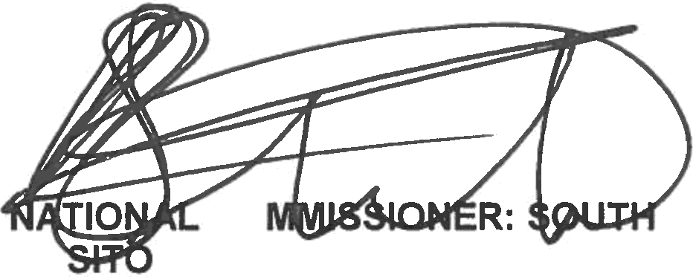
Reply to question 395 recommended d

cO
KJ LE (SOEG)
GENERAL AFRICAN POLICE SERVICE

Date:
2616 -6J- 6 6

Reply to question 395 approved/not approved

MINISTER OF POLICE
BH CELE, MP

Date:

