,*RIVATE BAG x 59, PRETORIA, 0001, T=l (012) 444 3979. Fax (0 12) 444 31J5
PRI*/ATE BAG x 9 111, CAPE TOWN. 600L t021 ) 462 2? 10. Fax (02 7 ) 461 08?J
Enqu\r es:

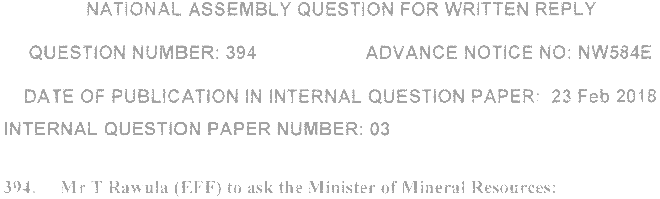
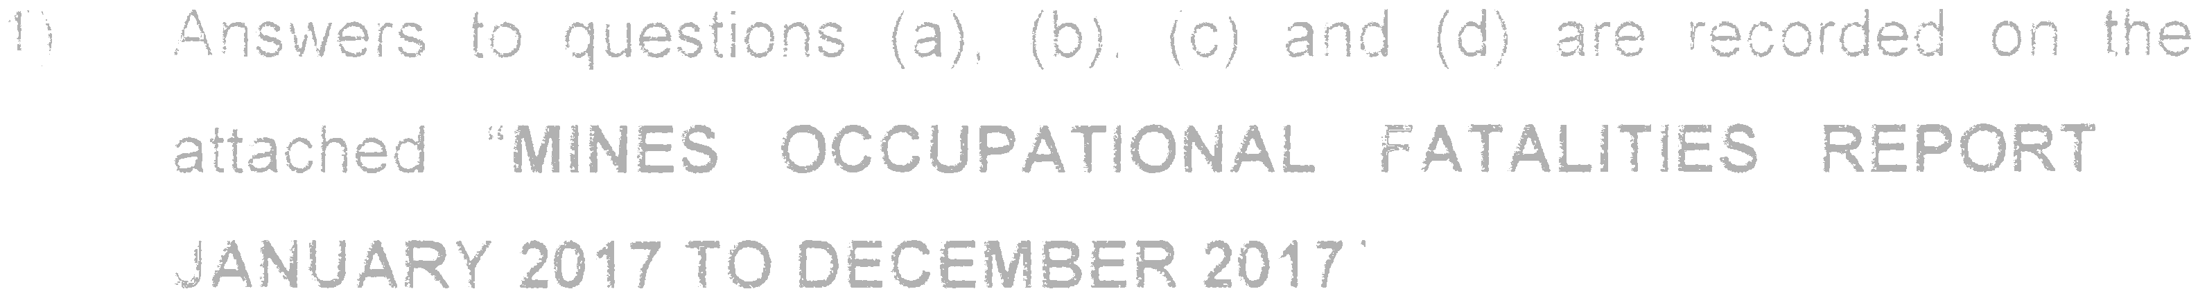
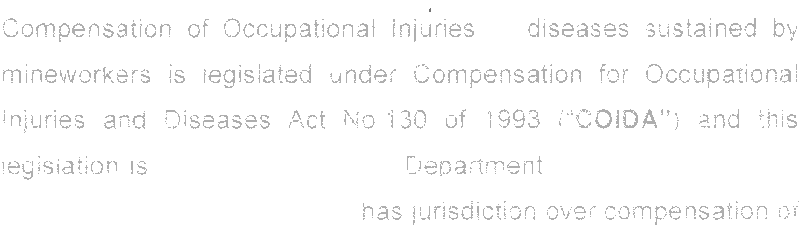
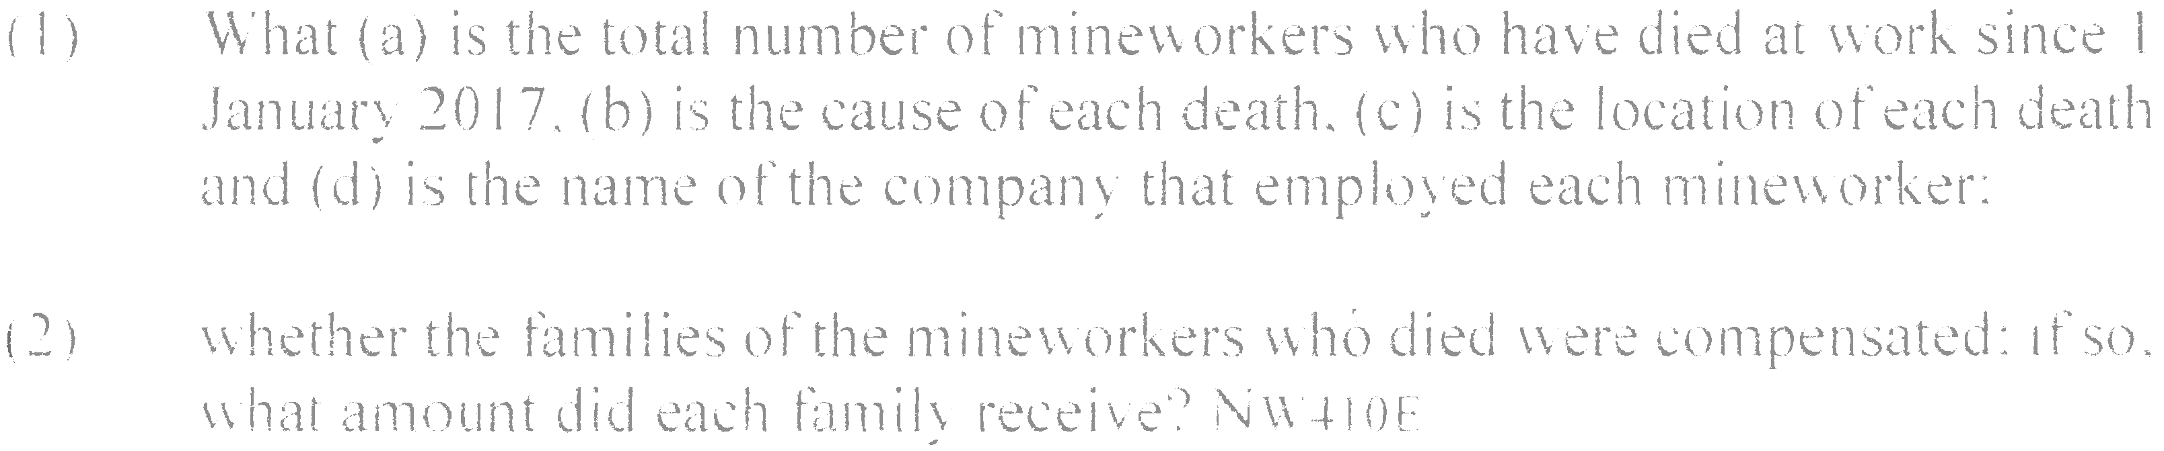

MINISTRY OF MINERAL RESOURCES REPUBLIC OF SOUTH AFRICA
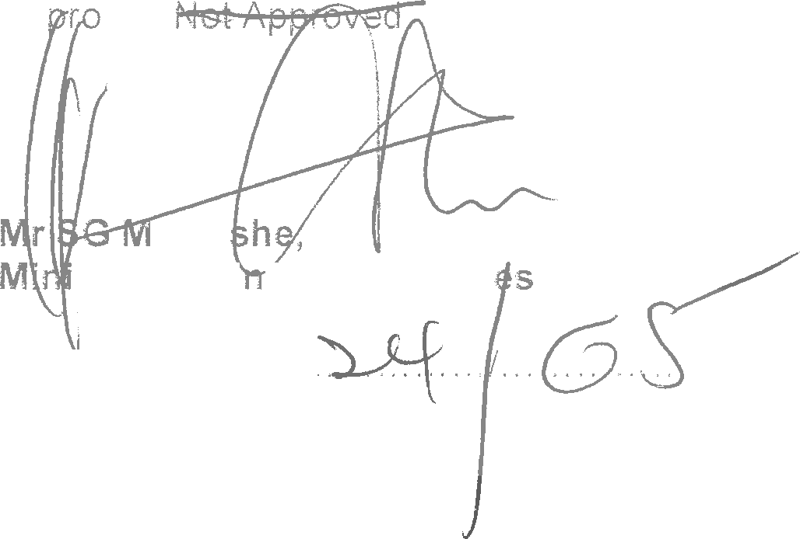
Ap »ed/
anta
ster of I\/li eral Resourc

Daté Submitted:-
/2018

