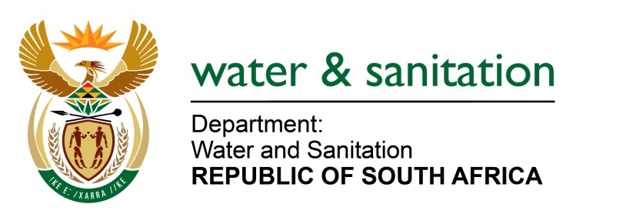

NATIONAL ASSEMBLY

FOR WRITTEN REPLY

QUESTION NO 3932

DATE OF PUBLICATION IN INTERNAL QUESTION PAPER: 28 OCTOBER 2022
(INTERNAL QUESTION PAPER NO. 42)

3932. Mrs M R Mohlala (EFF) to ask the Minister of Water and Sanitation:
What total amount has his department spent on replacing and/or refurbishing water infrastructure in the past five financial years, as 37% of drinking water was lost through pipe leakages and other infrastructure failures?
NW4896E
---00O00---
MINISTER OF WATER AND SANITATION

The amounts spent by the Department of Water and Sanitation to replace and refurbish water infrastructure in the past five financial years were spent on Water Trading Entity infrastructure and not municipal infrastructure where these losses are occuring.

The following amounts have been spent on replacing and/or refurbishing water infrastructure by the Water Trading Entity (WTE):

Financial Year | Total
 | R'000
2017/18 | 390 787
2018/19 | 177 123
2019/20 | 164 457
2020/21 | 137 315
2021/22 | 227 250
Grand Total | 1 096 932

The following amounts have been spent on replacing and/or refurbishing water infrastructure by the Main Account:

Financial Year | RBIG |  | WSIG |  | Total
 | 5B | 6B | 5B | 6B
2017/18 | 1 829 002 | 3 747 243 | 3 305 237 | 819 416 | 9 700 899
2018/19 | 1 963 000 | 3 061 848 | 4 777 267 | 578 398 | 10 380 514
2019/20 | 2 028 516 | 2 768 746 | 3 669 319 | 548 284 | 9 014 865
2020/21 | 2 005 605 | 2 998 971 | 3 360 456 | 330 186 | 8 695 218
2021/22 | 2 237 370 | 2 246 121 | 3 620 327 | 404 797 | 8 508 615
Grand Total | 10 063 493 | 14 822 930 | 18 732 606 | 2 681 081 | 46 300 110

---00O00---

