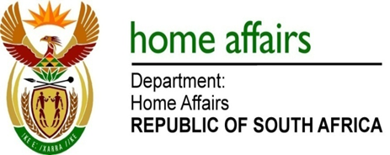

NATIONAL ASSEMBLY

QUESTION FOR WRITTEN REPLY

QUESTION NO. 3927

DATE OF PUBLICATION: Friday, 6 November 2015

INTERNAL QUESTION PAPER 48 OF 2015

3927. Mr M H Hoosen (DA) to ask the Minister of Home Affairs:
- What is the total number of uncollected new Smart ID Cards at his department in each province, since the introduction of the specified cards;
- What steps are being taken to issue the specified cards before the local government election that is scheduled for 2016? NW4792E
REPLY:

- The total number of uncollected Smart ID Cards at the department in each province as at 10 November 2015 is as follows :-

Free State : 12 832
Eastern Cape : 27 151
Kwazulu-Natal : 29 324
Western Cape : 20 027
Limpopo : 22 838
Gauteng : 43 476
Northern Cape : 7 071
North West : 13 456
Mpumalanga : 11 335
Gauteng (Banks ) : 289

Total : 187 799

- In order to ensure that Smart ID Cards which have already been issued are collected, applicants are informed when their Smart ID Cards are ready for collection via the SMS system utilised by the Department. An SMS is forwarded to confirm receipt of the Smart ID Card at the office of application for collection by the applicant.

Two follow-up reminder SMSs are also forwarded should the Smart ID Card not be collected by the applicant.

During izimbizo and outreach campaigns, citizens are also reminded to collect their Smart ID Cards.

