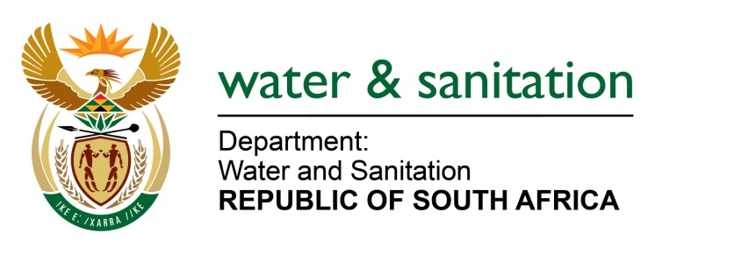

NATIONAL ASSEMBLY

FOR WRITTEN REPLY

QUESTION NO 3923

DATE OF PUBLICATION IN INTERNAL QUESTION PAPER: 1 DECEMBER 2017
(INTERNAL QUESTION PAPER NO. 47)
3923. Ms M S Khawula (EFF) to ask the Minister of Water and Sanitation:
(a) What is the total number of households that were moved to make space for the Nandoni Dam in Limpopo, (b) was a settlement agreement reached between her department and the households that were moved, (c) what is the total monetary value of the settlement, (d) what amount was given to each household and (e) what are the details of persons who have (i) received and (ii) not yet received the settlement as at 27 November 2017? NW4469E
---00O00---
REPLY:
- The total number of households that were moved to make space for the Nandoni Dam is 465 (which included recognition of families desiring to separate/divorce, one Musanda, three churches, one clinic, two business; one government and community buildings). These structural replacements should were separate from the relocation of 2 100 subsistence farmers.

- Yes, a settlement agreement was reached with the affected households/ community. The Relocation Action Plan (RAP) was developed with the project steering committee which comprised of provincial and territorial authorities.

- The total monetary value of the settlement is R 8,005,248.79.

- and (e)

It must be noted that the compensation system adopted to mitigate losses and other disadvantages caused by the project strived for reinstatement as a preferred option rather than monetary value. Where reinstatement was impractical or inadequate, resort was made to other forms of compensation. In addition to reinstatement, the following households were also compensated in monetary value.

See attached Annexure A.
---00O00---

