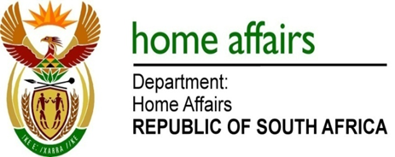

NATIONAL ASSEMBLY

QUESTION FOR WRITTEN REPLY

QUESTION NO. 3916

DATE OF PUBLICATION: FRIDAY, 24 NOVEMBER 2017

INTERNAL QUESTION PAPER 46 OF 2017

3916. Mr M Waters (DA) to ask the Minister of Home Affairs:

Have any investigations and/or audits been conducted into the Independent Electoral Commission (a) in the (i) 2014-15, (ii) 2015-16 financial years and (b) since 1 April 2017; if not, why not; if so, (aa) what was the nature of each investigation and/or audit, (bb) who conducted the investigation and/or audit, (cc) on what date was each investigation/audit completed, (dd) what were the recommendations of each investigation and/or audit report and (ee) by which date will each report be released? NW4463E
REPLY:

(a)(i) In 2014-15 no investigations and/or audits have been conducted into the Electoral Commission bar the normal audit conducted by the Auditor-General annually.
(a)(ii) In 2015-16 no investigations and/or audits have been conducted into the Electoral Commission bar the normal audit conducted by the Auditor-General annually.
- Since 1 April 2017 no issues were raised by the Auditor-General or brought on by any institution that required an investigation and/or audit
(aa) Not applicable
(bb) No investigations and/or audit done
(cc) Not applicable
(dd) Not applicable
(ee) Not applicable

