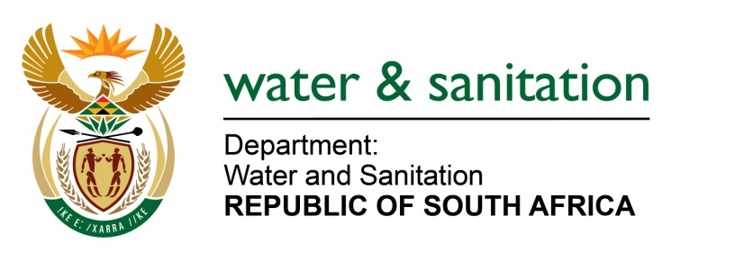

NATIONAL ASSEMBLY

**FOR WRITTEN REPLY**

**QUESTION NO 3914**

**DATE OF PUBLICATION IN INTERNAL QUESTION PAPER: 6 NOVEMBER 2015**

**(INTERNAL QUESTION PAPER NO. 48)**

**3914. Inkosi R N Cebekhulu (IFP) to ask the Minister of Water and Sanitation:**

With reference to the declaration of the province of KwaZulu-Natal as a disaster area on 30 October 2015, (a) what are the relevant details of the allocation of drought-relief assistance that will immediately be made available to provide drought relief to drought-stricken areas in the province and (b) what are the relevant details of any other departmental strategies that are in place to provide assistance to municipalities in the province which are struggling to provide relief because of a scarcity of resources? NW4771E

---00O00---

**REPLY:**

(a) In December 2014, my Department made an allocation of R354.2 million to assist with the mitigation of the impacts of the drought in KwaZulu-Natal. Additional funding has been made available (refer to the latest detailed Drought Intervention Budgets allocations attached as **Appendix1**).

(b) In November 2015, the Honourable Premier declared a Provincial State of Disaster due to the impacts of the drought in nine (9) of the ten (10) District Municipalities in KwaZulu-Natal. In terms of the Disaster Management Act, the Provincial Department of Cooperative Governance and Traditional Affairs (CoGTA) is responsible for the overall disaster management.

My Department’s strategy includes the following:

* The implementation of drought operating rules for ten (10) water supply schemes in KwaZulu-Natal. Drought operating rules are scientific tools used as a guide to manage the water resource(s) to protect it from failure by restricting water used during low flows in order to ensure that the water supply for essential water users e.g. basic human consumption can always be met. My Department gazetted water restrictions on 3 July 2015 and is monitoring the success of the restrictions and assisting with the development of alternative augmentation options where necessary.
* Ensuring System and District level Joint Operations Committees are established and regular meetings held in order to determine the necessary drought interventions and monitor the implementation thereof.
* Assisting the Water Services Authorities and Water Boards in the provision of water through the reprioritisation of R502 million for drought intervention projects.
* Assisting the Water Services Authorities with the provision of water through the supply and operation of 45 water tankers.
* Assisting the Department of CoGTA with the evaluation of water services authority intervention plans for inclusion into a Provincial Business Plan for the application to the National Disaster Management Centre for additional support.

---00O00---

**Appendix 1: Drought Intervention Budgets**



---00O00---