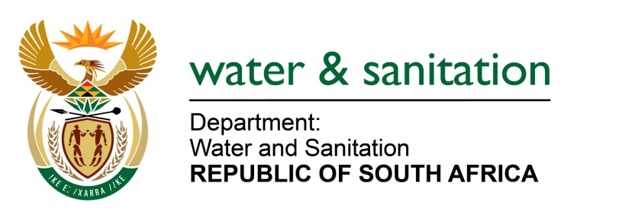

NATIONAL ASSEMBLY

FOR WRITTEN REPLY

QUESTION NO 3913

DATE OF PUBLICATION IN INTERNAL QUESTION PAPER: 28 OCTOBER 2022
(INTERNAL QUESTION PAPER NO. 42)

3913. Ms N Tafeni (EFF) to ask the Minister of Water and Sanitation:
(a) What is the total number of water boards that dissolved in the current financial year and (b) on what date will the new boards be appointed?
NW4877E
---00O00---

MINISTER OF WATER AND SANITATION

- To date, two (2) Boards for Water Boards, have been dissolved. The Board for Amatola Water was dissolved in March 2022 and the Interim Board of Sedibeng Water was automatically dissolved as a result of the disestablishment of Sedibeng Water in July 2022.

- The process of appointing the new board for Amatola Water has commenced, and it should be finalised before the end of the current financial year.

---00O00---

