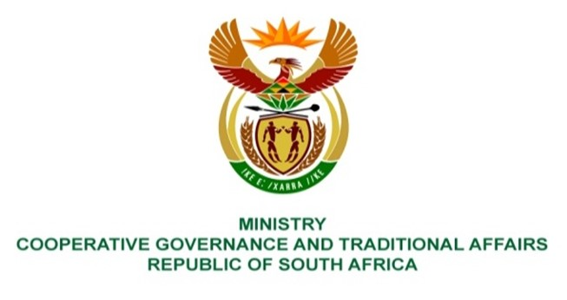

NATIONAL ASSEMBLY
QUESTIONS FOR WRITTEN REPLY

QUESTION NUMBER 3096
DATE OF PUBLICATION: 28 OCTOBER 2022

QUESTION:

3906. Mrs S M Mokgotho (EFF) to ask the Minister of Cooperative Governance and Traditional Affairs:
Whether she intends to take any steps to intervene in the Rustenburg Local Municipality (a) so that it constructs roads and (b) provides water to the community of Block 50 towards the side of Choppies at Boitekong; if not, why not; if so, what are the relevant details? NW4868E

REPLY:

- It is responsibility of municipalities working together with Department Transport to construct roads; and

- It is responsibility of municipalities working together with Department Water and Sanitation to provide water to communities.

It is recommended that this question be transferred to the relevant Ministries of the above-mentioned departments for written reply.

