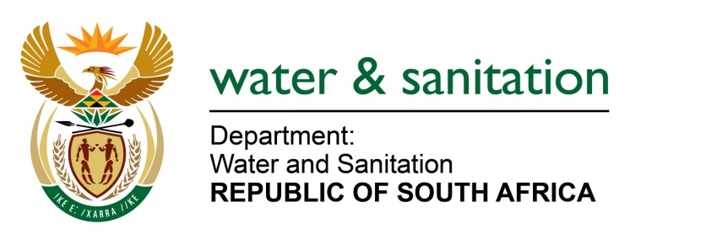

NATIONAL ASSEMBLY

FOR WRITTEN REPLY

QUESTION NO 3905

DATE OF PUBLICATION IN INTERNAL QUESTION PAPER: 28 OCTOBER 2022
(INTERNAL QUESTION PAPER NO. 42)

3905. Mrs S M Mokgotho (EFF) to ask the Minister of Water and Sanitation:
What plans did his department put in place to provide adequate water to residents of new stands at Boitekong in Rustenburg?
NW4867E
---00O00---

MINISTER OF WATER AND SANITATION

Due to the current high water demand exacerbated by the ongoing power outages, the Rustenburg Local Municipality (LM) is implementing water demand management in the greater Boitekong areas including the new stands (Extention 13). According to the Rustenburg LM, the water restrictions schedules have been communicated with relevant Ward Councillors and the affected residents.

In the medium to long term, funds have been made available through Municipal Infrastructure Grant (MIG) administered by Department of Cooperative Government and Traditional Affairs (COGTA) for the upgrade of Bospoort Water Treatment Works from the 12ML/d to 24ML/d. I have been advised that the outstanding mechanical and electrical works is envisaged to be completed by the end of June 2023. This will ensure adequate water provision to the Boitekong area.

---00O00---

