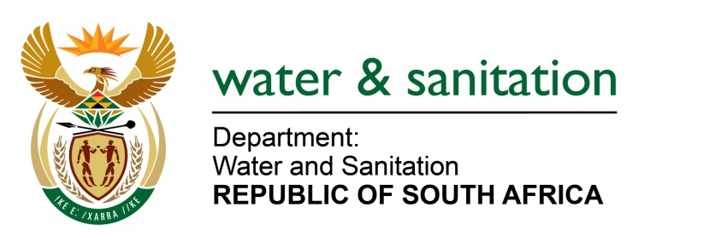

NATIONAL ASSEMBLY

FOR WRITTEN REPLY

QUESTION NO 3904

DATE OF PUBLICATION IN INTERNAL QUESTION PAPER: 28 OCTOBER 2022
(INTERNAL QUESTION PAPER NO. 42)

3904. Mrs S M Mokgotho (EFF) to ask the Minister of Water and Sanitation:

(1) By what date will his department install a sewer system for residents of Ward 40, Extension 8 in Rustenburg, who had put in a request for installation to his department in 2019 without any response to their application to date.

(2) whether he will furnish Mrs S M Mokgotho with the relevant details regarding the installation; if not, why not; if so, on what date?

NW4866E
---00O00---

MINISTER OF WATER AND SANITATION

The extension 8 housing development in Ward 40 was funded by the erstwhile Department of Housing in 2005. Two hundred (200) houses were constructed and handed over to beneficiaries. Whereas there was a sewer pipeline network in the areas at the time of construction, some of the houses were not connected to the sewer pipe network. According to the Municipality, the area is fully equipped with a sewerage conveyances system, the only challenge that exists is to connect the few houses to the sewer line.

The Department of Water and Sanitation allocated R70 million from the Water Services Infrastructure Grant for 2022/23 to the Rustenburg Local Municipality. The municipality indicated that it has prioritised the refurbishment of the Boitekong sewer pump station and the outfall sewer. The current budget allocation for WSIG is fully committed, however, the municipality is in the process of reprioritising the Municipal Infrastructure Grant to address the Boitekong sanitation backlog.

---00O00---

