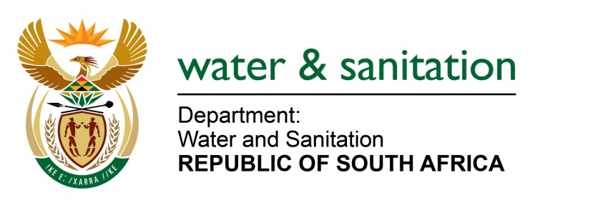

NATIONAL ASSEMBLY

FOR WRITTEN REPLY

QUESTION NO 3904

3904. Mr. WM Madisha (Cope) asked the Minister of Water and Sanitation:
(1) Whether her department has ascertained which municipalities are (a) lacking adequate infrastructure for the full and proper treatment of sewage, (b) releasing effluent from non-compliant or poorly functioning waste water treatment works into streams and dams, (c) unable to provide reliable bulk infrastructure sewerage collection services, (d) still using outdated or inefficient pump stations and (e) falling foul of the South African National Water Policy of 1996 and the National Water Act, Act 36 of 1998, in respect of not properly protecting aquatic ecosystems; if not, why not in each case; if so, (i) what steps has her department taken to rectify each specified situation fully and rapidly and (ii) to what extent has the specified steps succeeded in doing so? NW4691E
---00O00---

REPLY:

My Department is currently undertaking a comprehensive functional assessment of the 850 waste water treatment plants for South Africa.

The immediate priority and intervention is that my Department has appointed a professional service provider under its Regional Bulk Infrastructure Grant (RBIG) programme to deal with the 26 plants in the Vaal River System. This is in line with my Department’s National Campaign entitled War on Water Pollution.

---00O00---

