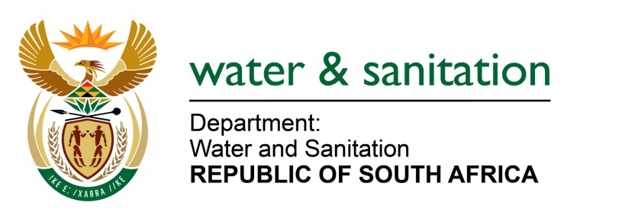

NATIONAL ASSEMBLY

FOR WRITTEN REPLY

QUESTION NO 390

DATE OF PUBLICATION IN INTERNAL QUESTION PAPER: 19 FEBRUARY 2016
(INTERNAL QUESTION PAPER NO. 2)

390. Dr G A Grootboom (DA) to ask the Minister of Water and Sanitation:
With reference to President Jacob G Zuma’s undertaking in his State of the Nation Address delivered on 12 February 2015, that the Government will set aside 30% of appropriate categories of state procurement for purchasing from Small, Medium and Micro-sized Enterprises (SMMEs), co-operatives, as well as township and rural enterprises, what percentage of the total procurement of (a) her department and (b) every entity reporting to her went to (i) SMMEs and (ii) co-operatives from 1 April 2015 up to the latest specified date for which information is available? NW402E
---00O00---
REPLY:

My department and its entities are performing well above the target of 30% in terms of procuring goods and services from Small, Medium and Micro-sized Enterprises (SMMEs).

---00O00---

