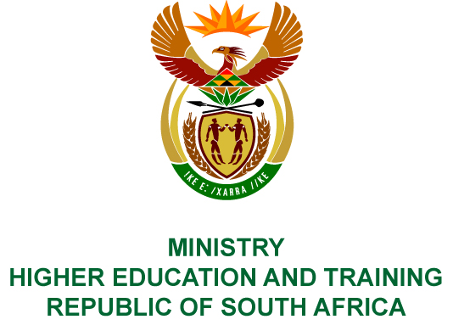
Private Bag X893, Pretoria, 0001, Tel (012) 312 5555, Fax (012) 323 5618
Private Bag X9192, Cape Town, 8000, Tel (021) 469 5150, Fax: (021) 465 7956
Memorandum from the Parliamentary Office
NATIONAL ASSEMBLY
FOR WRITTEN REPLY
QUESTION 39
DATE OF PUBLICATION OF INTERNAL QUESTION PAPER: 08/02/2018

(INTERNAL QUESTION PAPER NO 1 OF 2018)
Mr M Bagraim (DA) to ask the Minister of Higher Education and Training:
(a) What is the total number of courses for the training of domestic workers that were funded by the Culture, Arts, Tourism, Hospitality and Sport Sector Education and Training Authority, (b) on what date was each funding awarded, (c) for which courses was the funding awarded, (d) what is the value of each funding that was awarded, (e) why was each funding awarded and (f) what are the details of each recipient?
NW44E
REPLY:
The Culture, Arts, Tourism, Hospitality and Sports Sector Education and Training Authority funded no courses for domestic workers.

COMPILER DETAILS
NAME AND SURNAME: MR MABUZA NGUBANE
CONTACT: 012 312 5248
RECOMMENDATION
It is recommended that the Minister signs Parliamentary Question 39.

MR GF QONDE
DIRECTOR–GENERAL: HIGHER EDUCATION AND TRAINING
DATE:

PARLIAMENTARY QUESTION 39 IS APPROVED / NOT APPROVED / AMENDED.
COMMENT/S

PROF HB MKHIZE, MP
MINISTER OF HIGHER EDUCATION AND TRAINING
DATE:

