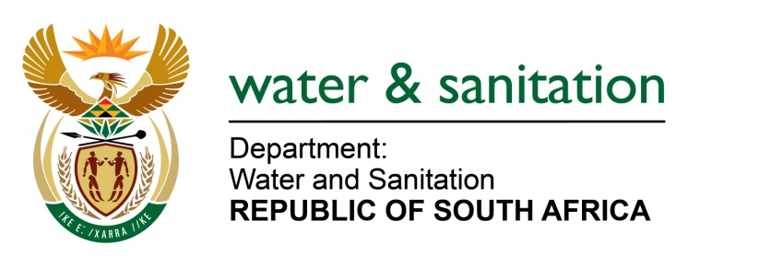

NATIONAL ASSEMBLY

FOR WRITTEN REPLY

QUESTION NO 3884

DATE OF PUBLICATION IN INTERNAL QUESTION PAPER: 30 OCTOBER 2015
(INTERNAL QUESTION PAPER NO. 45)

3884. Ms T E Baker (DA) to ask the Minister of Water and Sanitation:

With regard to the amount of R352 million allocated to the drought-stricken municipalities of KwaZulu-Natal, (a) how was this amount determined and (b) what audit or study was used to determine the amount required to alleviate the effects of the drought? NW4696E

---00O00---
REPLY:

- Following the Premier’s declaration of a Provincial State of Disaster in selected Municipalities in KwaZulu-Natal, I as the Minister of Water and Sanitation issued a Directive to my Director-General on 20 December 2014 to provide R352.4 million for interventions to mitigate the impact of the drought. The amount was determined at a meeting between my Director-General, Head of Department of the Provincial Department of Cooperative Governance and Traditional Affairs (CoGTA) and the Water Services Authorities (WSAs) on
8 December 2014.

The Provincial Department of CoGTA collected, collated and co-ordinated the evaluation of the WSAs implementation plans. The provincial Drought Relief Implementation Plan dated 22 January 2015 highlighted that an estimated R669.7 million was required to alleviate the drought in the Province and an application for the balance of the funding was made to National Disaster Management Centre.

- The WSAs submitted their implementation plans to the CoGTA who then coordinated the evaluation of the plans.

---00O00---

