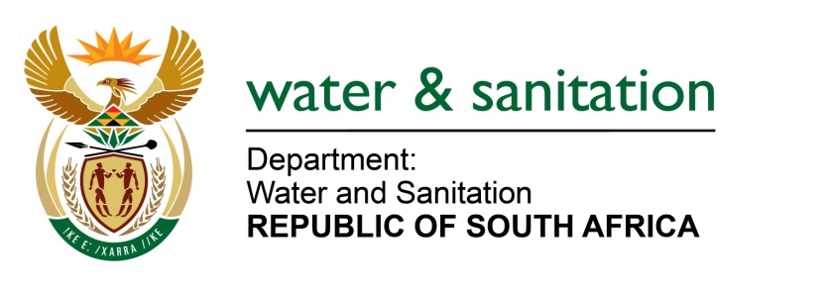

NATIONAL ASSEMBLY

FOR WRITTEN REPLY

QUESTION NO 3883

DATE OF PUBLICATION IN INTERNAL QUESTION PAPER: 30 OCTOBER 2015
(INTERNAL QUESTION PAPER NO. 45)

3883. Ms T E Baker (DA) to ask the Minister of Water and Sanitation:
(1) What is the (a) current risk status of the Kwena Dam in Mpumalanga and (b) reason for the specified risk;
(2) (a) when was the most recent water quality test done at the specified dam and (b) what was the result of the specified test? NW4695E

---00O00---
REPLY:

(1)(a) The current risk is that, the Kwena Dam volume is dropping rapidly; on Monday 26 October 2015 the dam volume was 74% full.

(1)(b) Due to significantly below normal rainfall and the extreme high temperatures currently being experienced in the Inkomati Water Management Area, river flow levels in the Crocodile River are extremely low.

(2)(a) The most recent water quality test for the Kwena Dam was done in October 2015. It should be noted that water quality tests are done on monthly basis.

(2)(b) The water quality results for October 2015 have not been received yet from the laboratory that does the analysis. However, the water quality results for the month of September 2015 are indicated on the table 1 below:

Table 1
Variables | September results
Electrical conductivity | 12.6 mS/m
pH | 7.25 pH units
Iron | 0.63 µg/l
Manganese | 0.14 µg/l
Escherichia coli | 4 counts/100ml
Ammonia Nitrogen | 0.082 mg/l
Nitrate +Nitrite | 0.27 mg/l
Orthophosphate | 0.2 mg/l

---00O00---

