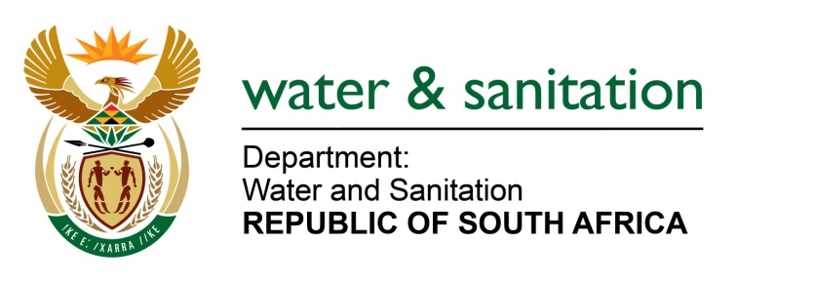
EdTM

NATIONAL ASSEMBLY

FOR WRITTEN REPLY

QUESTION NO 3882

DATE OF PUBLICATION IN INTERNAL QUESTION PAPER: 30 OCTOBER 2015
(INTERNAL QUESTION PAPER NO. 45)

3882. Mrs Z B N Balindlela (DA) to ask the Minister of Water and Sanitation:
(1) (a) When was the most recent pH level test conducted on the Olifants River and (b) what were the results;
(2) what is the cause of the high acidity levels of the specified river;
(3) whether she has taken any steps to remedy the situation; if not, why not; if so, what are the relevant details? NW4694E

---00O00---
REPLY:
(1)(a)The most recent pH level test conducted on the Olifants River was in September
2015.
(1)(b) The results range on average from 5.5 to 8.5.
- The cause of the high acidity levels of the specified river can generally be attributed to agricultural, mining and industrial activities.
(3) Yes, my Department is conducting routine and targeted compliance monitoring inspections and audits on a regular basis, and where a transgressor is found, enforcement actions are undertaken. The classification, determination of the Resource Quality Objectives (RQOs) and the reserve of the Olifants River is being determined.
---00O00---

