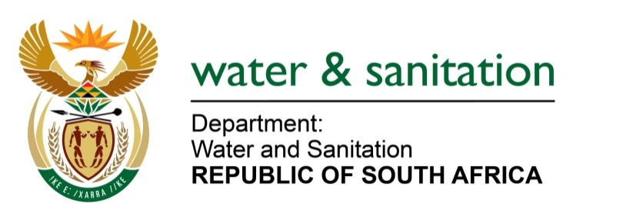

NATIONAL ASSEMBLY

FOR WRITTEN REPLY

QUESTION NO 3881

DATE OF PUBLICATION IN INTERNAL QUESTION PAPER: 30 OCTOBER 2015
(INTERNAL QUESTION PAPER NO. 45)

3881. Ms T E Baker (DA) to ask the Minister of Water and Sanitation:
(1) With reference to the Wastewater Risk Abatement Plan (W2RAP) of August 2010, (a) which five municipalities are considered to be the most at risk and (b) what is the nature (i) of such risks and (ii) for high risk areas;
(2) whether she has implemented any intervention measures to address the risk factors; if not, why not; if so, what are the relevant details? NW4693E

---00O00---
REPLY:
(1) No municipalities have been reported to be at risk.

(2) The Wastewater Risk Abatement Plan (W2RAP) of August 2010 was developed only as a municipality managerial tool to assist municipalities to take ownership of the plans in order to identify and mitigate against risks in their wastewater services.

The W2RAP was not intended to categorise which municipalities are highest at risk but instead it was intended to assist them to know the risks in their daily operations and make plans to mitigate against such risks.
---00O00---

