NATIONAL ASSEMBLY QUESTION FOR WRITTEN REPLY QUESTION NUMBER: 3880
DATE OF PUBLICATION IN INTERNAL QUESTION PAPER: 28 OCTOBER 2022 INTERNAL QUESTION PAPER NUMBER: 42 - 2022

3880. Ms L L van der Merwe (IFP) to ask the Minister of Social Development:

With regard to her department’s call centre, (a) what (i) total number of calls are received on average in each month and (ii) number of the specified calls are prank calls and (b) what total number of (iii) calls are not related to issues of gender-based violence and (iv) total gender-based violence cases are successfully attended to in each month through the call centre?
NW4838E

REPLY:
a) (i) The department’s call centre during the period April 2022 – October 2022 received a total number of 4148 calls average per month.

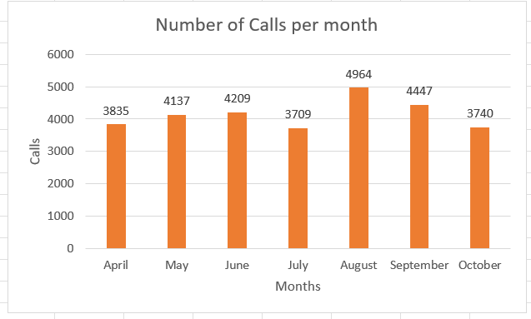

ii) Currently GBVCC does not have a system to identify prank callers, all cases are treated as real cases. It is only after many times and or months that a specific official will determine if it is a prank call. Their numbers will reflect as regular callers. Victims of GBVF can sometimes call and drop calls when facing threats, which makes it difficult to always determine prank callers. There are also regular callers who either give feedback, refer cases or need further assistance. This is an area for development.

- A total number of 2648 calls were received during the period April –October 2022 that are not related to issues of gender-based violence

Incident Type | Number of Calls Received: Non GBV Cases

 | April | May | June | July | August | Septemb er | October | Total
Anger Management | 2 | 3 | 2 | 2 | 3 | 2 | 7 | 21
Behavioural Problems | 4 | 9 | 7 | 7 | 5 | 7 | 10 | 49
Child Adoption | 1 | 4 | 3 | 0 | 0 | 1 | 0 | 9
Child Custody/Visitation | 12 | 23 | 20 | 10 | 12 | 13 | 10 | 100
Child Maintenance | 7 | 4 | 9 | 9 | 8 | 2 | 8 | 47
Counselling Death | 1 | 0 | 1 | 1 | 3 | 0 | 0 | 6
Counselling Depression | 7 | 14 | 17 | 13 | 21 | 8 | 5 | 85
Counselling Marriage &  Relationships | 22 | 44 | 32 | 18 | 47 | 35 | 35 | 233
COVID - 19 | 0 | 1 | 0 | 0 | 0 | 0 | 0 | 1
Economic/Financial Abuse | 0 | 0 | 0 | 0 | 5 | 1 | 2 | 8
Funding | 0 | 2 | 1 | 1 | 1 | 1 | 2 | 8
Home Affairs Related | 9 | 3 | 7 | 2 | 4 | 1 | 5 | 31
 | 0 | 0 | 0 | 0 | 0 | 0 | 0 | 0
Labour Dispute | 3 | 2 | 2 | 0 | 3 | 3 | 1 | 14
Legal Advice | 6 | 11 | 7 | 2 | 12 | 14 | 5 | 57
Matric | 0 | 0 | 0 | 0 | 0 | 1 | 1 | 2
Other type of Incident | 241 | 270 | 218 | 231 | 384 | 213 | 232 | 1789
SASSA Grants | 19 | 13 | 25 | 12 | 10 | 15 | 14 | 108
Substance Abuse | 8 | 12 | 17 | 8 | 17 | 9 | 9 | 80
Xenophobia | 0 | 0 | 0 | 0 | 0 | 0 | 0 | 0
Total | 342 | 415 | 368 | 316 | 535 | 326 | 346 | 2648

- A total number of 1958 Gender-based violence cases were successfully attended to in each month through the call Centre during the period

Incident Type | Number of Calls Received: GBV Cases
 | April | May | June | July | August | Septembe r | October | Total
Abandoned Children | 2 | 3 | 2 | 0 | 0 | 0 | 0 | 7
Abduction/ Kidnapping | 2 | 1 | 2 | 1 | 2 | 3 | 0 | 11
Assault | 9 | 13 | 6 | 10 | 12 | 14 | 11 | 75
Bullying | 2 | 2 | 3 | 2 | 6 | 2 | 4 | 21
Child Neglect | 20 | 42 | 38 | 16 | 35 | 29 | 18 | 198
Child Pornography | 0 | 0 | 0 | 0 | 0 | 0 | 0 | 0
Elderly Neglect | 2 | 5 | 1 | 7 | 8 | 4 | 6 | 33
Emotional Abuse | 41 | 33 | 35 | 37 | 41 | 49 | 28 | 264
Forced Initiation | 1 | 0 | 0 | 0 | 0 | 0 | 0 | 1
Forced Prostitution | 0 | 0 | 0 | 0 | 0 | 0 | 0 | 0
Hate Speech | 0 | 0 | 0 | 0 | 0 | 0 | 1 | 1
Human Trafficking | 0 | 1 | 0 | 1 | 0 | 0 | 1 | 3
Incest | 0 | 1 | 0 | 0 | 0 | 0 | 1 | 2
Indecent Assault | 1 | 0 | 0 | 0 | 0 | 0 | 0 | 1
Molestation | 0 | 0 | 3 | 1 | 0 | 1 | 1 | 6
Physical Violence | 155 | 175 | 113 | 122 | 158 | 137 | 125 | 985
Rape/Corrective Rape | 16 | 34 | 29 | 15 | 23 | 27 | 22 | 166
Sexual Harassment | 1 | 2 | 3 | 0 | 3 | 0 | 0 | 9
Stalking | 0 | 2 | 0 | 2 | 2 | 2 | 1 | 9
Verbal Abuse or  Intimidation | 24 | 25 | 24 | 24 | 27 | 26 | 16 | 166
Total | 276 | 339 | 259 | 238 | 317 | 294 | 235 | 1958

