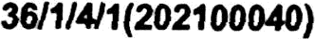
KATIO AL ASSEMBLY

N REPL’

UESTION 388

DATE OF PUBLICATION IH INTERNAL
UESTION PAPER: 19 FEBRUARY
INTERXAL UESTION PAPER NO 2-2021

388. Us Z Majozl (IFP) to ask the Minister of Poliæ:
In liqht of the faQ that the SA Police Service (SAPS) in Gauteng has œme Drward and eaffirmed its œmmlment to desisively deal with taxi violenæ and find SAPS members who are involved in illegally providing taxi operators and
h y' men with ûearms (details fumished), what measues has the SAPS in

Gauteng pz in place to cuö œrruption and disœuage it all together,

(2) whether he will furnish Ms Z Majozi with figues that will give a clear and contextual image of the progess made in this regard; if not, why not; 1so, what ae the elevant details?
REPLY:

The performance of remunerative work by employees of the South African Police Service (SAPS) is regulated by National Instruction 4 of 2012, which prohibits the performance of any remunerative work in the taxi industry.

Paragraph 3 of National Instruction 4 of 2012, Performance of Remunerative Work, lists the prohibitions on the granting of approval to an employee, to perform certain types of remunerative work or to perform certain a4iv•rties for gain. The tax‹ industry is listed in paragraph 3(a), which reads: Approval may not be granted to an employee to perform any remunerative work •f such work or activity is in any manner connected to the taxi industry. This includes, but is not limled to, the operation of a taxi service by the employee, himsel or herseP or by employing another person, or the performance of remunerative work for a taxi association, group of taxi owners or operator or for a
single taxi owner or operator.

Any information, relating to the involvement of SAPS membem in the taxi industry. is followed up immediately by the Provincial Investigation Team.

de following measures are in place, with ægafd to the management of SAPs fileams:
O III SAPS fireams are accounted for, on a regular basis, by means of physical inspections.
o All SAPS fifBarITIS aæ dot paen marked and tested, in tems of the lntegrated BalliStiCS Identification System (IBIS) and record is kept for comparison with exhibits, recovered at crime scènes.

In order tg corruption, the following measures have been implemented:
- All the SAPS personnel, who are attached to the Taxi Violence Investigation Unit, are vetted and lifestyle audits are conducted on a regular basis.
- Corruption cases are investigated by the Anti-Corruption Unit.
- Allegations of corruption are investigated departmentally, independently from the criminal case.
- Employees face dismissal if found guilty on corruption charges.
- Employees are sensitised about the consequence of committing serious misconduct.
» Roll out of the National Instruction on ethics and integrity management.
- Trainees are subjected to integrity management to eliminate the potential risk of corruption.

The following SAPS members were convicted and dismissed for their involvement in taxi violence:

Station and Cæe Number | Charge | Name of SAPS Member | SAPS  Flrearm
Gemiston  CAS 289/11/2015 | Murder x 2 and  attempted murder | Thulani Wiseman  Madidie | N | Guilty- 2 x life imprisonment
 |  | Lungisani Arnold Mgaga | yyy | Guilty- life imprisonment
Roodepoort  CAS 579/10/2018 | Murder | Sibusiso Shongwe | No | Guilty- life imprisonment

3

Reply to question 388 recommended/

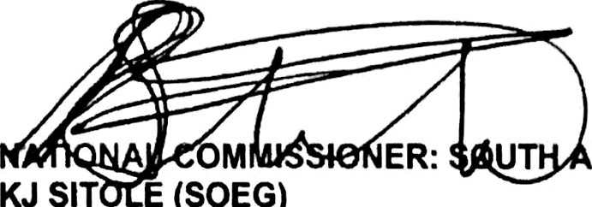
GENERAL
M ER: UT FRICAN POLICE SERVICE KJ SIT E (SOEG)
Date: ) ttt -tt-‹ ‹
Reply to question 388 approved/not approved

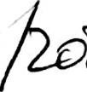MINIS OF POLICE GENERAL B CELE, MP
Date: Q

