NATIONAL ASSEMBLY
36/1/4/1(201900050)

FOR WRITTEN REPLY

QUESTION 388

DATE OF PUBLICATION IN INTERNAL QUESTION PAPER: 22 FEBRUARY 2019 (INTERNAL QUESTION PAPER NO 3-2019)

388. Mr D J Stubbe (DA) to ask the Minister of Police:

What number of (a) children and (b) adults were reported as missing in the (i) 2015- 16, (ii) 2016-17 and (iii) 2017-18 financial years?
NW412E
REPLY:

(a)(b)(i)(ii)(iii)

(i) 2015/2016 |  | (ii) 2016/2017 |  | (iii) 2017/2018
Children | Adults | Children | Adults | Children | Adults
839 | 3 529 | 902 | 3 454 | 861 | 3 793

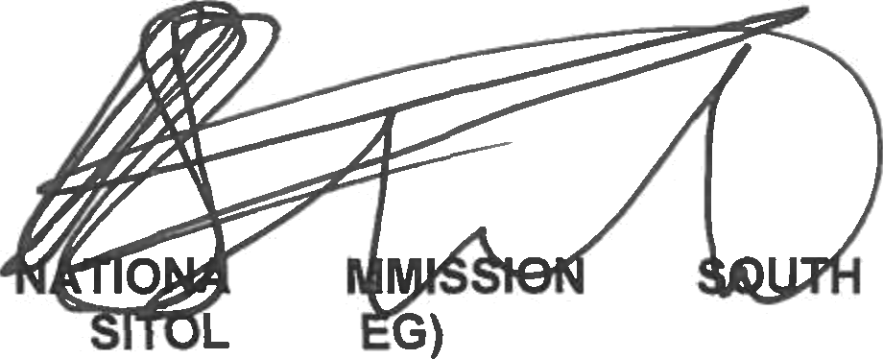
Reply to question 388 recommended/ined

L CO
KJ E (SO
Date: zs16 -tt- s s

ER:

GENERAL AFRICAN POLICE SERVICE

Reply to question 388 approved/

MINISTEROFPOL!CE BHCELE,MP
Date:

