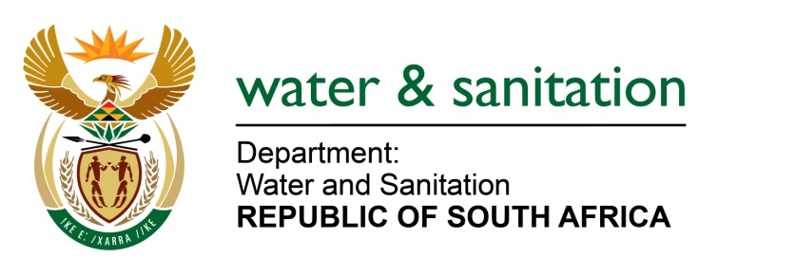

NATIONAL ASSEMBLY

FOR WRITTEN REPLY

QUESTION NO 3879

DATE OF PUBLICATION IN INTERNAL QUESTION PAPER: 30 OCTOBER 2015
(INTERNAL QUESTION PAPER NO. 45)

3879. Mrs Z B N Balindlela (DA) asked the Minister of Water and Sanitation:
(1) With reference to her reply to question 3376 on 7 October 2015, for each of the 19 cases mentioned, (a) what is the name of each waste water treatment works (WWTW) where the spillage occurred, (b) what was the latest Green Drop rating of each WWTW, (c) in which municipality is each WWTW situated and (d) what was the nature of the spillage in each case;
(2) whether each specified WWTW has a water use licence; if not, why not;
(3) whether any progress has been made with regard to each of the 19 cases; if not, why not; if so, what are the relevant details in each case;
(4) whether any additional cases have been reported since 7 October 2015; if so, (a) what is the name of each WWTW where the spillage occurred, (b) what is each specified WWTW's latest Green Drop rating, (c) in which municipality is each WWTW situated and (d) what was the nature of the spillage in each case;
(5) whether the specified WWTW has a water use licence; if not, why not? NW4691E
---00O00---

REPLY:

Refer to Annexure A for the list of WWTW where the spillages occurred, progress and additional cases reported. The Blue and Green Drop reports, is still due to be submitted to Cabinet for approval in line with the exercise of executive authority in terms of section 85 of the Constitution.

---00O00---

Annexure A

No | Name of WWTW | Name of Municipality | Nature of Spillage | Water Use License
 | Alexandria WWTW | Ndlambe Local Municipality | Untreated sewer discharged into the environment from the WWTW. | No Water Use Licence application submitted.
 | Cradock WWTW | Chris Hani District Municipality | Final effluent discharged not meeting prescribed General Standard limit. | General Authorisation by the Regional Office
 | Bothaville WWTW | Nala Local Municipality | Final effluent discharged not meeting prescribed General Standard limit and malfunctioning pump station causing spillage. | No Water Use Licence application submitted.
 | Manhole overflow | Mangaung Metro | Spillage at the manhole due to presence of solids in system. | Not Applicable
 | Deneysville WWTW and Refengkgotso Pumpstation | Metsimaholo Local Municipality | Final effluent discharged not meeting prescribed General Standards limit and malfunction at the pump station causing sewer spillage. | Not Applicable
 | No WWTW linked to the sewer line. | Ekurhuleni Metro Municipality | Spillage at the manhole due to presence of solids in system. | Not Applicable
 | Mokopane WWTW | Mogalakwena Local Municipality | Spillage at the manhole due to presence of solids in system. | No Authorisation
 | Matibidi District Hospital WWTW | Matibidi District Hospital WWTW | Untreated sewer discharged into the environment from the WWTW. | No Authorisation
 | Thabazimbi WWTW | Thabazimbi Local Municipality- | Final effluent not meeting limits prescribed in the Water Use License. | Authorised:  Licence Issued for 21(c,f,g&i) 07/02/2014
 | Barkley East WWTW | Joe Gqabi DM - Burgersdorp | Untreated sewer discharged into the environment from the WWTW.
 | Ekangala WWTW | Tshwane Metropolitan | Untreated sewer discharged into the environment from the WWTW.
 | Wemmershoek WWTW | Stellenbosch Local Municipality | Final effluent not meeting prescribed General Standards limit
 | Kathu WWTW | Gamagara Local Municipality | Untreated sewer discharged into the environment from the WWTW.
 | Dibeng WWTW | Gamagara Local Municipality | Final effluent not meeting prescribed General Standards limit.
 | Dingleton WWTW | Gamagara Local Municipality | Untreated sewer discharged into the environment from the WWTW.
 | Olifantshoek WWTW | Gamagara Local Municipality | Final effluent not meeting prescribed General Standards limit.
 | Barkley West WWTW | Dikgatlong Local Municipality | Untreated sewer discharged into the environment from the WWTW.
 | Warrenton WWTW | Magareng Local Municipality | Final effluent not meeting prescribed General Standards limit.
 | Randfontein WWTW | Randfontein Local Municipality | Untreated sewer discharged into the environment from the WWTW.

No | Name of WWTW | Name of Municipality | Nature of Spillage
 | Standerton WWTW | Lekwa Local Municipality | Final effluent not meeting prescribed General Standards limit.
 | Bothaville WWTW | Nala Local Municipality | Final effluent not meeting prescribed General Standards limit.
 | Viljoenskroon WWTW | Moqhaka Local Municipality | Final effluent not meeting prescribed General Standards limit.

